Appendix 1. Location of Cueva de Los Guácharos National Park (Huila, Colombia), indicated by the star mark. Green represents forested areas, pink colors represent recently deforested areas, deep blue represents young secondary forests and white and brown areas indicate crops, grassland and urban areas. (Source: Global Forest Watch. www.globalforestwatch.org)
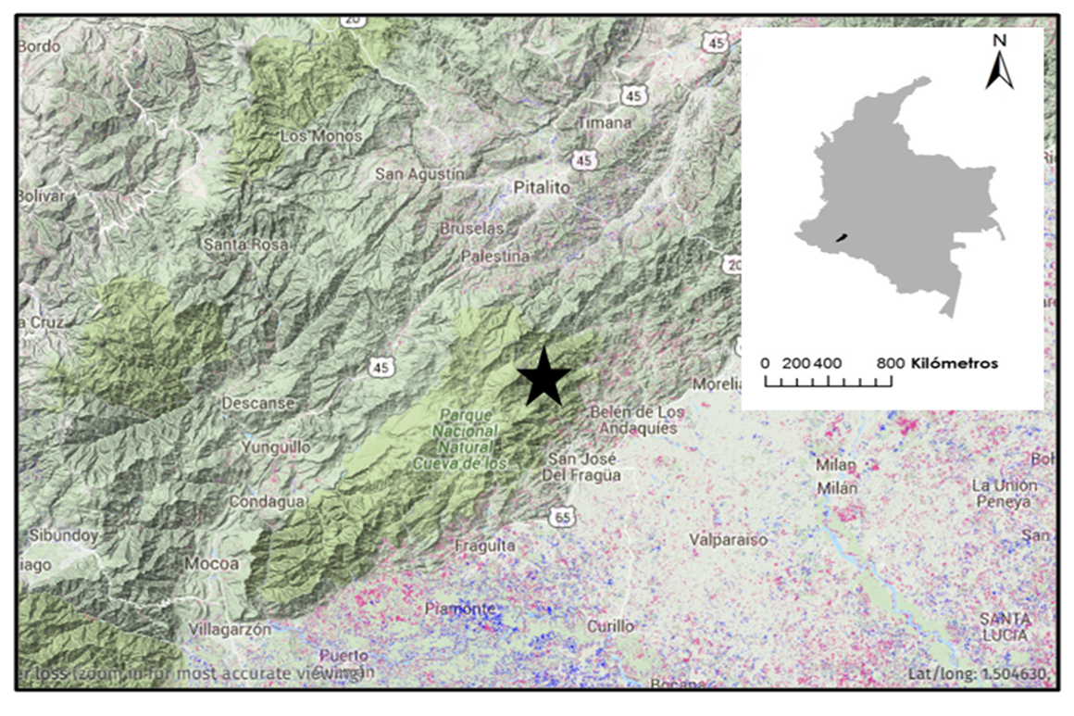

Appendix 2. Density of seeds dropped by Oilbirds (Steatornis caripensis) at traps located in the wall and in the center of the main cave in Cueva de Los Guácharos National Park, (Huila, Colombia), between April 18 and 22, 2011.
