Online Resource 1. Location of Cueva de Los Guácharos National Park (Huila, Colombia). Green represents forested areas, pink colors represent recently deforested areas, deep blue represents young secondary forests and white and brown areas indicate crops, grassland and urban areas. (Source: Global Forest Watch. www.globalforestwatch.org)
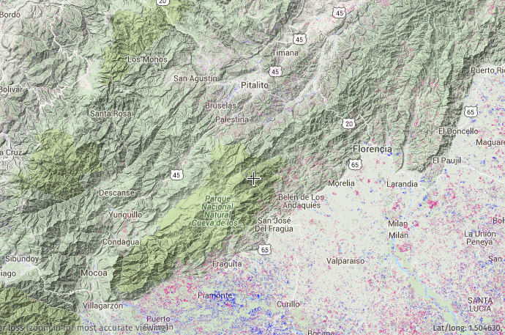

Online Resource 2. Density of seeds at traps located in the wall and in the center of the main cave in Cueva de los Guácharos National Park, (Huila, Colombia).
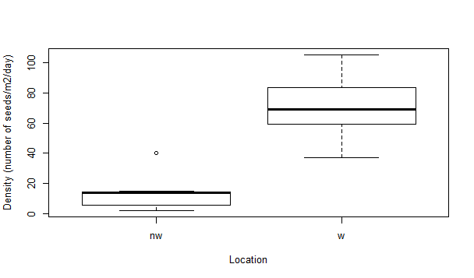
Location
Wall cave
Center cave
Density (seeds.m⁻².day)

Online Resource 3. Calculation of Importance Index of plants (a) species and (b) families of Oilbird diet recorder between 2011 and 2015 in the main cave of Cueva de los Guácharos National Park (Huila – Colombia).
a)
Species | Relative Density (%) | Relative Frequency (ln%) | Relative Dominance (%) | Importance Index
Prestoea acuminata | 35.00 | 4.61 | 13.23 | 52.84
Lauraceae (lr) | 26.03 | 4.42 | 7.92 | 38.37
Lauraceae (pg) | 4.03 | 4.07 | 19.47 | 27.57
Geonoma sp. | 18.66 | 4.61 | 2.04 | 25.31
Dacryodes sp. | 1.94 | 4.42 | 12.19 | 18.55
Nectandra cf. purpurea | 2.76 | 4.32 | 8.33 | 15.41
Euterpe precatoria | 3.69 | 4.20 | 3.46 | 11.35
Nectandra sp. | 4.19 | 4.52 | 1.89 | 10.60
Lauraceae (ag) | 0.73 | 3.51 | 5.09 | 9.33
Hedyosmum cf. cuatrecazanum | 4.41 | 4.61 | 0.05 | 9.07
Lauraceae (m) | 1.33 | 4.32 | 2.33 | 7.98
Lauraceae (rr) | 2.60 | 4.32 | 0.76 | 7.68
Chamaedorea linearis | 1.71 | 4.07 | 1.62 | 7.40
Lauraceae (cal) | 2.04 | 3.91 | 0.87 | 6.82
Dendropanax cf. macrocarpus | 1.82 | 4.52 | 0.07 | 6.41
Bactris sp. | 1.01 | 4.07 | 1.18 | 6.26
Oenocarpus minor | 1.04 | 4.32 | 1.44 | 5.76
Oenocarpus bataua | 1.28 | 4.32 | 1.10 | 5.42
Rodostemonodaphne grandis | 0.22 | 3.51 | 1.59 | 5.32
Persea sp. | 0.79 | 3.51 | 1.00 | 5.30
Lauraceae (gua) | 0.26 | 4.07 | 0.17 | 4.50
Humiriaceae (pa) | 0.18 | 3.91 | 0.41 | 4.50
Lauraceae (rgi) | 0.32 | 2.12 | 1.54 | 3.98
Trattinnickia sp. | 0.53 | 2.78 | 0.29 | 3.60
Aiphanes sp. | 0.10 | 3.22 | 0.19 | 3.51
Lauraceae (peg) | 0.66 | 2.12 | 0.64 | 3.42
Lauraceae (palo) | 0.06 | 3.22 | 0.05 | 3.33
Lauraceae (rc) | 0.08 | 2.12 | 0.48 | 2.68

b)

Family | Relative Density (%) | Relative Frequency (ln%) | Relative Dominance (%) | Importance Index
Arecaceae | 53.78 | 4.61 | 52.50 | 110.88
Lauraceae | 38.51 | 4.61 | 37.19 | 80.31
Burseraceae | 3.78 | 4.61 | 1.11 | 13.01
Chloranthaceae | 2.22 | 4.52 | 6.27 | 9.50
Araliaceae | 1.56 | 4.52 | 2.82 | 8.90
Humiriaceae | 0.15 | 3.91 | 0.11 | 4.17

Online Resource 4. Occupied nests by Oilbirds inside the cave of Cueva de los Guácharos National Park (Huila – Colombia) in 2015. Data was recorder by the National Park staff.

Month | Year
 | 2014 | 2015
Jan | - | 959
Feb | - | 948
Mar | - | 976
Apr | - | 928
May | 882 | 907
Jun | 559 | 675
Jul | 189 | 65
Aug | 82 | 20
Sep | 131 | 31
Oct | 206 | 98
Nov | 615 | 172
Dic | 740 | 535

Online Resource 5. Lipid content of fruits known to be eaten by Oilbirds in different studies.
Species | Family | % lipids | Reference
Bactris gasipaes | Arecaceae | 5.4 | Rojas. G. 2012
Bactris gasipaes | Arecaceae | 4.6 | Gongora. Lopez & Young 1953 in: Bernal & Correa. 1998
Bactris gasipaes | Arecaceae | 4.4 | Leung 1961 in: Bernal & Correa. 1998
Bactris gasipaes | Arecaceae | 0.8 | Villachica 1996 in: Bernal & Correa. 1998
Bactris setulosa | Arecaceae | 28.3 | Bosque et al. 1995
Ceroxylon quindiuense | Arecaceae | 2.4 | Rojas. G. 2012
Chamaedorea linearis | Arecaceae | 1.8 | Rojas. G. 2012
Euterpe precatoria | Arecaceae | 0.3 | Rojas. G. 2012
Euterpe precatoria | Arecaceae | 8.0 | Bosque et al. 1995
Prestoea acuminata | Arecaceae | 1.1 | Bosque et al. 1995
Geonoma densa | Arecaceae | 5.5 | Bosque et al. 1995
Geonoma webwebaueri | Arecaceae | 1.5 | Rojas. G. 2012
Oenocarpus bataua | Arecaceae | 12.4 | Rojas. G. 2012
Oenocarpus bataua | Arecaceae | 19.7 | Bosque et al. 1995
Persea caerulea | Lauraceae | 10.3 | Rojas. G. 2012
Aniba perutilis | Lauraceae | 2.3 | Rojas. G. 2012
Nectandra acutifolia | Lauraceae | 32.0 | Rojas. G. 2012
Beilschmedia sulcata | Lauraceae | 33.3 | Bosque et al. 1995
Nectandra aff. laurel | Lauraceae | 63.2 | Bosque et al. 1995
Nectandra membranacea | Lauraceae | 67.8 | Bosque et al. 1995
Nectandra turbacensis | Lauraceae | 60.2 | Bosque et al. 1995
Ocotea aff. austinii | Lauraceae | 54.8 | Bosque et al. 1995
Ocotea floribunda | Lauraceae | 52.4 | Bosque et al. 1995
Ocotea sp. | Lauraceae | 36.0 | Bosque et al. 1995
Persea caerulea | Lauraceae | 46.5 | Bosque et al. 1995
Phoebe cinnamomifolia | Lauraceae | 34.0 | Bosque et al. 1995
Dacryodes trinitensis | Burseraceae | 2.5 | Bosque et al. 1995
Myrcianthes leucoxyla | Myrtaceae | 1.0 | Rojas. G. 2012
Araliaceae sp. | Araliaceae | 3.6 | Bosque et al. 1995

Online Resource 6. Species accumulation curve for the first sampling period in 2015, including 10 days of seed sampling in the main cave at Cueva de Los Guacharos National Park.
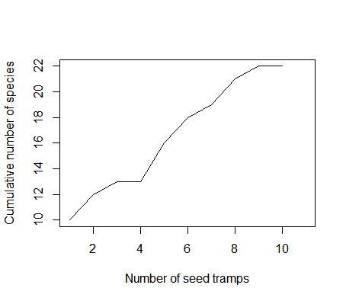

Online Resource 7. Seedlings of germinated seeds inside the main cave of Cueva de los Guácharos National Park (Huila, Colombia).
