Supplementary information: an extract of the training manual provided to biosphere expedition members participating in monitoring of the macaw claylick (2016 version).

Parrot and Macaw behaviour training

2.1 Introduction

All over south-eastern Peru animals of various types have been observed eating clay (called geophagy). One of the most colourful and predictable spectacles of geophagy is observed in the early mornings on exposed banks of clay where parrots (including macaws and parakeets) gather in large numbers to descend to the clay. This spectacle is one of the most important and reliable tourist attractions, affected only by weather and time of year. Our expedition coincides with the period of low macaw activity, but high parrot activity. The importance of sodium in the soil is becoming increasingly established, but birds often arrive at the claylick that do not appear to feed. The social importance of claylicks has yet to be fully understood. The behaviours we record will allow us to compare social behaviour under different situations. We have previously investigated proportions of behaviour and have shown that behaviour changes according to the time of day, and in response to the number of birds around. This was based on focal observations of selected birds. As we are watching macaws during the low season, we will take the opportunity to conduct perch scans, i.e. document the behaviour of all macaws we can.

We record behaviour for two key species: Red-and-green macaws and ‘green’ parrot species e.g. Mealy Parrot and Blue-headed Parrot. Green parrot species usually visit for the first hour or two in the morning, while macaws are observed for the rest of the day.

2.2 Completing the claylick data sheet

Using the telescope on low magnification (20x as opposed to 60x) start a scan of the upper canopy, then the lower canopy, and then the claylick, from left to right. For each bird seen, spend no more than five seconds of observation to determine the bird’s predominant behaviour according to the categories below. Ideally this should be your first impression of what the bird is doing, i.e. a snapshot. Only spend more time if you are not able to see the bird well. Describe what the bird is doing to the person recording the data, who should mark the most relevant box. A perch scan is conducted every five minutes. Ideally, one should not record behavior for the same individual twice during a period, but if you are unsure (some birds flew from left to right, i.e. the direction of your scan), then do record behavior. If there are no parrots in the vicinity, please record time and weather and boats every 15 minutes rather than every 5 minutes.

The columns

First of all, you have to write the time of your observation using the 24 hour clock (e.g. 3 pm is 15:00). After that, the weather is recorded as percentage cloud (as per transects from 0 to 100%; or fog or rain; wind as none, light or heavy).

In the grey box below time and weather, record the direction of any boats passing the claylick for the period preceding the time you recorded in the row above, i.e. sequence of recording events is 1: write the time, 2: record the boats, 3: record the birds. Ob = outboard driven motor boats (such as our boat); Peke = the loud long-shafted boats used by woodcutters or locals, e.g. Ob: up, down, up

Now you are ready to record the behaviour of the individual birds. Here you have the list of definitions related to parrot behaviours. The less frequently observed behaviours are marked in the ‘other’ column using the prefixes on the bottom of the data sheet.

Parrot behaviour terminology

Vigilant: Vigilance is how alert a bird is. A vigilant bird is actively looking around; head movement is notable, often with head twisted at 90 degrees from the body so that the bird is looking up at the sky or down at the ground. Neck is usually stretched

Sleeping. If the bird’s eye is closed for longer than 10 seconds it should be considered sleeping. Often, but not always, the head may be turned around over the back. Sometimes, the bird that is sleeping stands just on one foot. Often the plumage of a sleeping bird is fluffed up and the body looks fat and round.

Resting. Bird is perched with head low (towards the shoulders), usually looking forward, maybe looking slowly around, but not doing much else.

Panting: Beak is open and tongue moving up and down, much like a dog.

Walking: Bird is walking along a branch or between branches, or on the claylick.

Calling: Bird is vocalising – beak is open and call can be heard.

Playing: Bird or birds engaged in robust movements, involving hanging upside down, squawking, gentle lunging. Distinguished from fighting which is very loud, and occurs very quickly, with wings stretched open.

Kissing: Bird grapples the beak of a partner bird. Sometimes they use tongues.

Aggression: Bird lunges with beak open at another bird.

Submission: Bird retreats from an aggressive bird, either backing away or flying off.

Fighting: Two birds are engaged in loud strident calls, lots of wing flapping. Fights are normally fairly short with the loser flying off.

Wingstretch: Bird opens a wing or both its wings in a stretch and does not fly away, associated with preening. It is not necessary to record wingstretch for activities where wings are typically open, e.g. playing or fighting.

Preening: Bird is grooming itself with its beak.

Allopreening: If at any stage the bird you are watching either preens another bird or is preened by another bird

Scratch: Bird uses its foot to groom.

Branch biting: Bird is using its beak to bite the branch it is on or tear leaves off its perch. Not to be confused with bird using its beak to balance itself as it moves along a branch.

Eating: Birds on the clay normally are doing this, but birds in the trees may have clay they have taken from the claylick. Normally the bird holds clay in one foot, balancing on the other, and pecks at the clay from time to time.

Short flight: Observed bird flies from one branch to another and stays within sight

Flight away: The bird takes off and continues flying for more than 5 seconds.

Headshake: This is normally a quick shaking movement of the head. Sometimes is associated with a bird being bothered by insects; other times is just to reorganise the feathers of the head.

Begging: Juvenile and soliciting females emit a slow “erp, erp, erp…” noise, accompanied by fluffed-up head feathers; usually done in the presence of an adult bird (parent or mate).

Regurgitation: An adult responds to a begging juvenile by bobbing its head vigorously before joining beaks and regurgitating food.

Defecation. Observed bird poops.

Eating plant: Any feeding behaviour observed in the trees around the claylick, including leaves.

Sex: Birds are seen mating.

A visual guide to some red-and-green macaw behaviour categories
Photos © Alan T. K. Lee

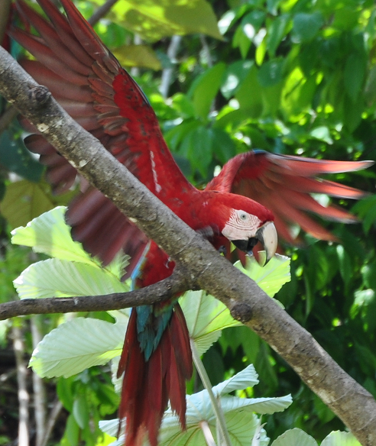 | 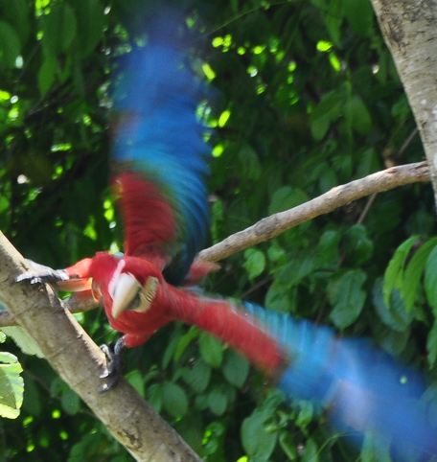
Red-and-green macaw in aggressive pose | Submissive response to another bird’s aggression
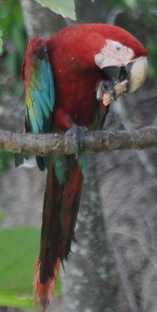 | 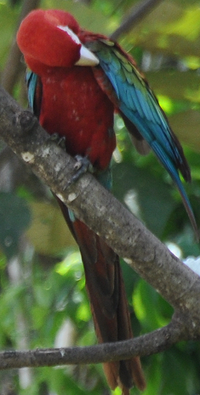
Eating clay in the trees, note clay in the foot | Preening
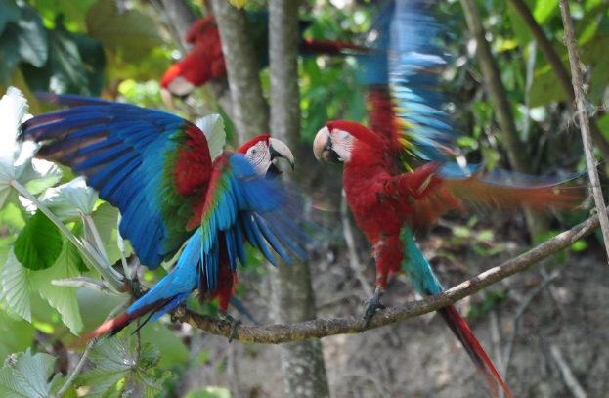 | 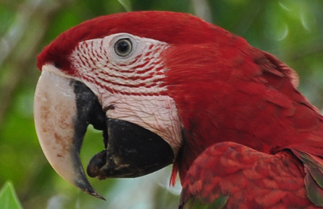
Fighting pose | Panting
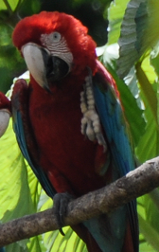 | 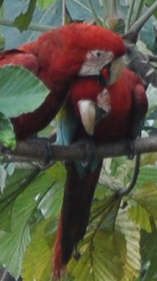
Scratching | Allopreening
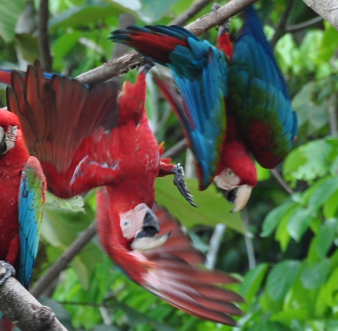 | 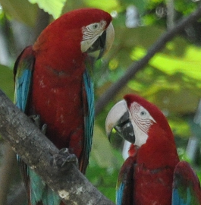
Playing | Vigilance
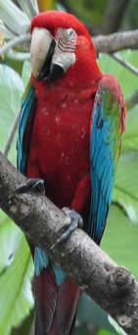 | 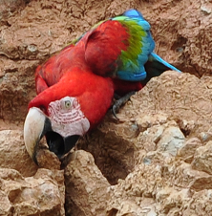
Resting | Eating clay on the claylick

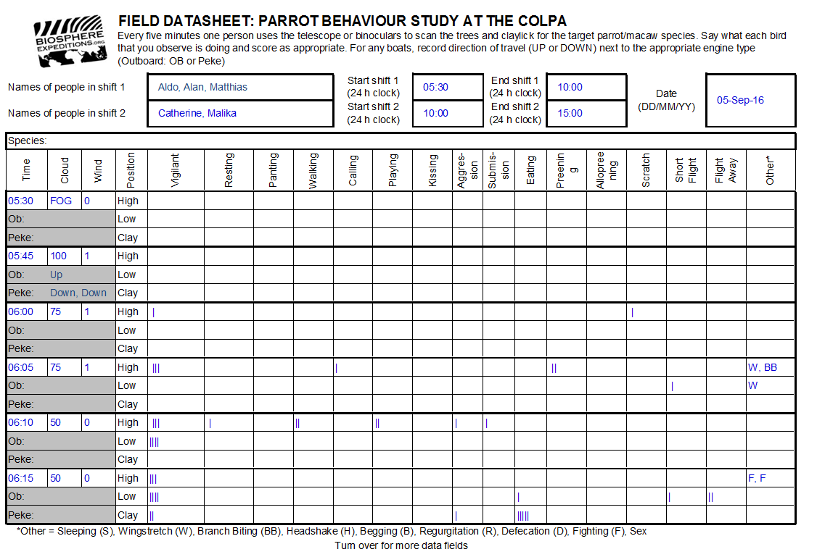
Example of completed datasheet
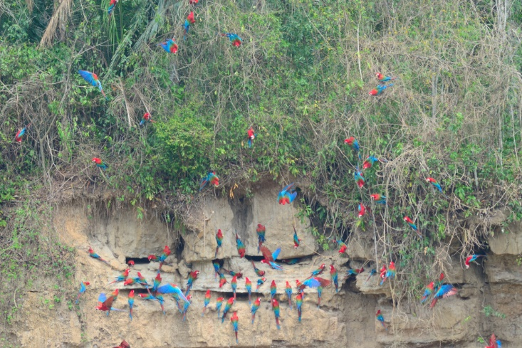

Red-and-green macaws low in the vegetation and on the claylick

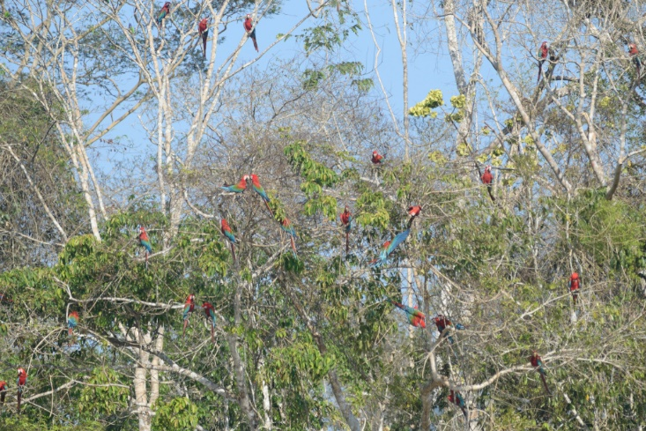
The distinction between LOW and HIGH in the vegetation is made easy by the appearance of the skyline behind trees classed as HIGH.

