Potable Water and Terrestrial Resources on Grand Bahama Post-Hurricane Dorian: Opportunities for Climate Resilience

Kristen Welsh^{1*}, Clare Bowen-O'Connor², Mark Stephens², Zoi Dokou³, Anne Imig⁴, Tara Mackey⁵, Andrew Moxey⁶, Efthymios Nikolopoulos⁷, Arno Rein⁴, Amber Turner¹, Amano Williams⁸, Layla Al Baghdadi³, John Bowleg⁹, Henrique Leite Chaves¹⁰, Ancilleno Davis¹¹, Gil Guberman¹², Danielle Hanek⁸, Sophia Klausner⁴, Dmitry Medlev¹³, Nivea Mazzoni¹⁴, Ingeria Miller⁸, Latonya Williams ^{1,8}, Remington Wilchcombe¹⁵

¹ University of The Bahamas, Small Island Sustainability Programme, Nassau, Bahamas
² University of The Bahamas, School of Chemistry, Environmental, and Life Sciences, Nassau, Bahamas
³ California State University-Sacramento, Civil Engineering Department, Sacramento, CA, United States
⁴ Technical University of Munich, Chair of Hydrogeology, School of Engineering and Design, Munich, Germany
⁵ Agile Consulting, Nassau, Bahamas
⁶ University of The Bahamas-North, School of Chemistry, Environmental, and Life Sciences, Freeport, Bahamas
⁷ Rutgers University, Civil and Environmental Engineering, New Jersey, USA
⁸ The Forestry Unit, Ministry of the Environment & Natural Resources, Nassau, Bahamas
⁹ UNESCO-IHP, UNESCO Bahamas Commission, Nassau, Bahamas
¹⁰ University of Brasilia, Watershed Management Lab, EFL – School of Technology, Brasilia-DF, Brazil
¹¹ Science and Perspective, Nassau, Bahamas
¹² Innovation: Africa, Israel
¹³ IsraAID, Israel
¹⁴ Davies Associates Ltd., Freeport, Bahamas
¹⁵ Grand Bahama Utility Company, Freeport, Bahamas

*Corresponding author, kristen.unwala@ub.edu.bs

Abstract

The catastrophic impact of Hurricane Dorian in 2019 was unprecedented for the island of Grand Bahama. Flooding in the western portion of the island damaged the pine ecosystems, inundated the soil and groundwater with salt water, and disrupted potable water service throughout the island. More than two years post-Hurricane Dorian the freshwater lenses that the island relies on for potable water are still inundated with salt water. This collaborative paper summarizes all efforts of researchers and practitioners to evaluate the freshwater lenses, as well as their associated ecosystems, that serve as the main source of drinking water for the island of Grand Bahama. Hydrogeologic and vegetation assessments were conducted of two primary wellfields that provide 95% of the drinking water to the island, over the span of two and a half years from the immediate aftermath of Hurricane Dorian through present day. While salinity and total dissolved solid concentrations in groundwater have declined, present levels indicate that the full recovery of the freshwater lenses may take many years. Forest assessments indicate that in Wellfield 6, which was the primary source of potable water pre-Hurricane Dorian, the pine forests suffered significant damage with complete pine mortality and little regeneration of pine trees occurring. Management strategies for restoring the freshwater lenses, adapting potable water sources, and addressing forest damage are discussed. Lessons learned from this event underscore the dramatic impact that climate change is having upon the islands of The Bahamas and the critical need for adaptation strategies to plan for future extreme events throughout the archipelago.

1. Introduction

On September 1-3, 2019, Hurricane Dorian devastated the islands of Abaco and Grand Bahama. Classified as Category 5 on the Saffir-Simpson Hurricane Wind Scale, Dorian became the strongest hurricane to impact The Bahamas in recorded history, with wind speeds over 160 kt, or 184 mph (Avila et al., 2020; Cerrai et al. 2020). On September 2, the hurricane made landfall over the eastern end of Grand Bahama and stalled over the island for more than a day (Caribbean Disaster Emergency Management Agency, 2019; Cerrai et al. 2020). An estimated accumulated precipitation of greater than 1000 mm occurred over the course of 3 days in eastern portions of the island (Cerrai et al. 2020) (see Figure 1). Storm surge and flooding led to a measured water level over 2.0 m greater than the mean water high tide in western portions of Grand Bahama and upwards of 6.4 m of flooding in some regions (Avila et al., 2020). On September 4, after the passing of the hurricane, approximately 14% of the island was still flooded (Cerrai et al. 2020).

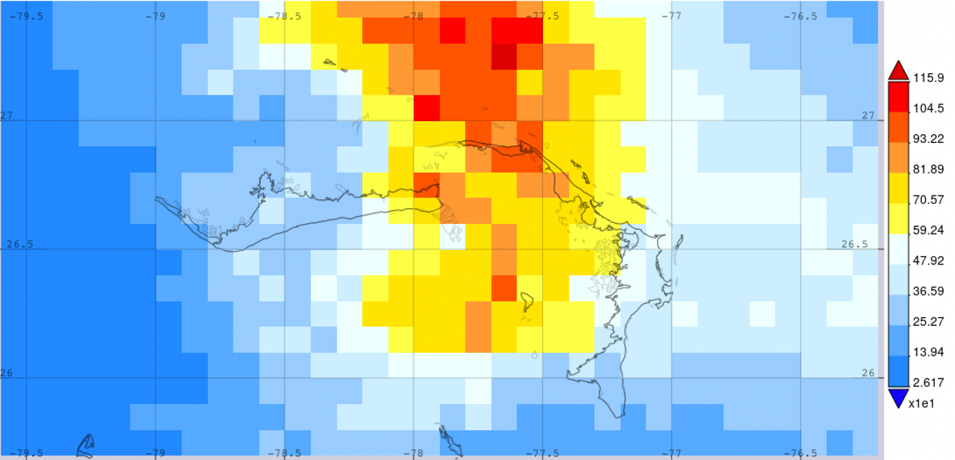
Figure 1. Map of total accumulated precipitation for the period 09/01 to 09/04, 2019 derived from NASA IMERG v06 Final Run. The graph was generated using the NASA GIOVANNI system (https://giovanni.gsfc.nasa.gov/).

Prior to Hurricane Dorian, Grand Bahama was the island with the second greatest abundance of freshwater (US Army Corps of Engineers [USACE], 2004). The island was solely reliant on groundwater aquifers for its drinking water sources, through freshwater lenses that lie atop denser saline water. Ninety-five per cent of the drinking water for the island originated from two major wellfields, with an additional wellfield providing 5% of the water source. Prior to Hurricane Dorian, an annual pumping rate of 3 billion gallons of water was obtained from these wellfields, with a recharge rate of 4.5 billion gallons of water.

As a result of Hurricane Dorian, the two primary wellfields that provided 95% of the water to the island experienced flooding and saltwater inundation. The terrestrial resources of western Grand Bahama were adversely impacted as flooding over the freshwater aquifers persisted for weeks, altering the hydrogeology and ecosystems in the regions of the two primary wellfields. Saltwater inundation of the aquifer significantly disrupted potable water provision to the island. In addition, the island experienced widespread mortality of stands of commercial Caribbean Pine (Pinus caribaea var. bahamensis), saturated soils, and the deposition of a layer of sediment (~6-7 cm thick silt crust) as floodwaters receded.

Drinking water on Grand Bahama is managed by the Grand Bahama Utility Company (GBUC), a private utility company. GBUC initially pumped water from the least saline wells to promote recovery of the freshwater lens (Chaves, 2021). However, due to extensive mixing that had occurred during flooding, initial pumping tests proved unsuccessful at remediating the salt inundation of the wellfield or restoring the freshwater lens. For an average of 2-3 weeks, residents across the island did not have potable water access in their homes. Individuals accessed emergency drinking water sources through disaster relief aid organizations. Given the importance in providing water to eastern Grand Bahama, GBUC was compelled to extract brackish water from W6 for residential distribution. Water that was flowing to homes was not initially potable, and even two years following Dorian 30% of water in the distribution network was not potable. In addition to having to buy bottled water, affected Bahamians experienced negative effects from the high salinity in the supplied water, such as corroded faucets and pipes in their houses.

As a result of extensive flooding and subsequent saltwater inundation of the aquifer, residents were subjected to poor drinking water quality for approximately one month post-Hurricane Dorian (Turner, 2022). The inundation of freshwater reservoirs resulted in brackish water to be emitted from taps in homes until complete potability was achieved. The flow of brackish water in homes resulted in residents being provided water at no cost from non-governmental organizations and GBUC. The water provided by GBUC was collected from another wellfield on the island and driven to specific sites to provide freshwater. With water being such a crucial part of daily routines, the lack of potable water affected the lives of residents in numerous ways. Complete restoration of potable water service occurred on October 28, 2021, when a portable reverse osmosis system began operation. This system purified saline water that was pumped from W6 and distributed to communities.

Grand Bahama has experienced similar saltwater inundation of the freshwater lenses during previous hurricanes. In 1995, storm surge from Hurricane Floyd resulted in significant flooding that inundated the wellfields (USACE, 2004) with observations of inundations up to 1.12 m in some areas (Mazzoni, 2013). Additionally, in 2004 both Hurricanes Jeanne and Frances resulted in approximately 2 m of storm surge and flood waters in the wellfields (USACE, 2004). Following these hurricanes, pumping efforts were undertaken to extract the saltwater inundating the aquifers and to restore the freshwater lens. Inundation levels after Hurricanes Wilma (2005), Irene (2011), and Sandy (2012) were observed at 2.44 m, 0.6 m, and 1.3 m, respectively, in portions of Grand Bahama (Mazzoni, 2013). While historic events caused storm surge and flooding, Hurricane Dorian resulted in the greatest amount of flooding at 6.4 m. Imagery analysis indicates that at least 45% of eastern Grand Bahama was flooded due to Hurricane Dorian, with estimates in western Grand Bahama lacking on account of imagery constraints (Cerrai et al., 2020).

Due to the unprecedented impact that Hurricane Dorian had on the drinking water sources and ecosystems on the island of Grand Bahama, multiple studies have been conducted on the wellfields of the island to assess damage and identify potential solutions. This paper outlines the initial and ongoing assessment and recovery efforts undertaken on the wellfields and their associated ecosystems on Grand Bahama over the two and a half years following Hurricane Dorian. Potential strategies for recovering the wellfields are highlighted, in addition to research opportunities that have emerged from this event.

2. Study Site

Grand Bahama is among the northernmost islands in the Bahamian archipelago and the second most populous island in the country after New Providence. With a land surface of approximately 1,373 km², the island is relatively flat with the highest elevation at 20.7 m above sea level (USACE, 2004). Subaerial and subsurface carbonates are the predominant lithology on Grand Bahama, and although not supporting surface waters they host meteoric groundwater which is controlled by poorly stratified non-skeletal shallow-water limestones of the Pleistocene Lucayan Formation (Mylroie et al., 1995; Carew and Mylroie, 1997). This limestone on the Little Bahama Bank is ~15–30 m thick and rests on dolomite below; over Grand Bahama, the limestone unit has a nearly uniform thickness of ~20 m (Vahrenkamp et al., 1991). In a study by Whitaker and Smart (2005), mean hydraulic conductivity for the Lucayan limestone was determined to be 1200 m/d based on pumping tests at different locations in Grand Bahama.

GBUC manages six wellfields to extract groundwater for drinking water supply on the island. The study sites are Wellfield 1 (W1) and Wellfield 6 (W6), located in the western portion of Grand Bahama (See Figure 2). Prior to Hurricane Dorian, 95% of the drinking water was sourced from these two wells, with 35% of the water extracted from W1 and 60% extracted from W6. Wellfield 3 provided the remaining 5% of drinking water. W1 is located in an urban area of the northwestern region of the city of Freeport with land cover primarily consisting of pine forests and residential homes. W6 is located northeast of the city limits and has a land cover of Bahamas pine forests with unpaved dirt roads throughout the region.

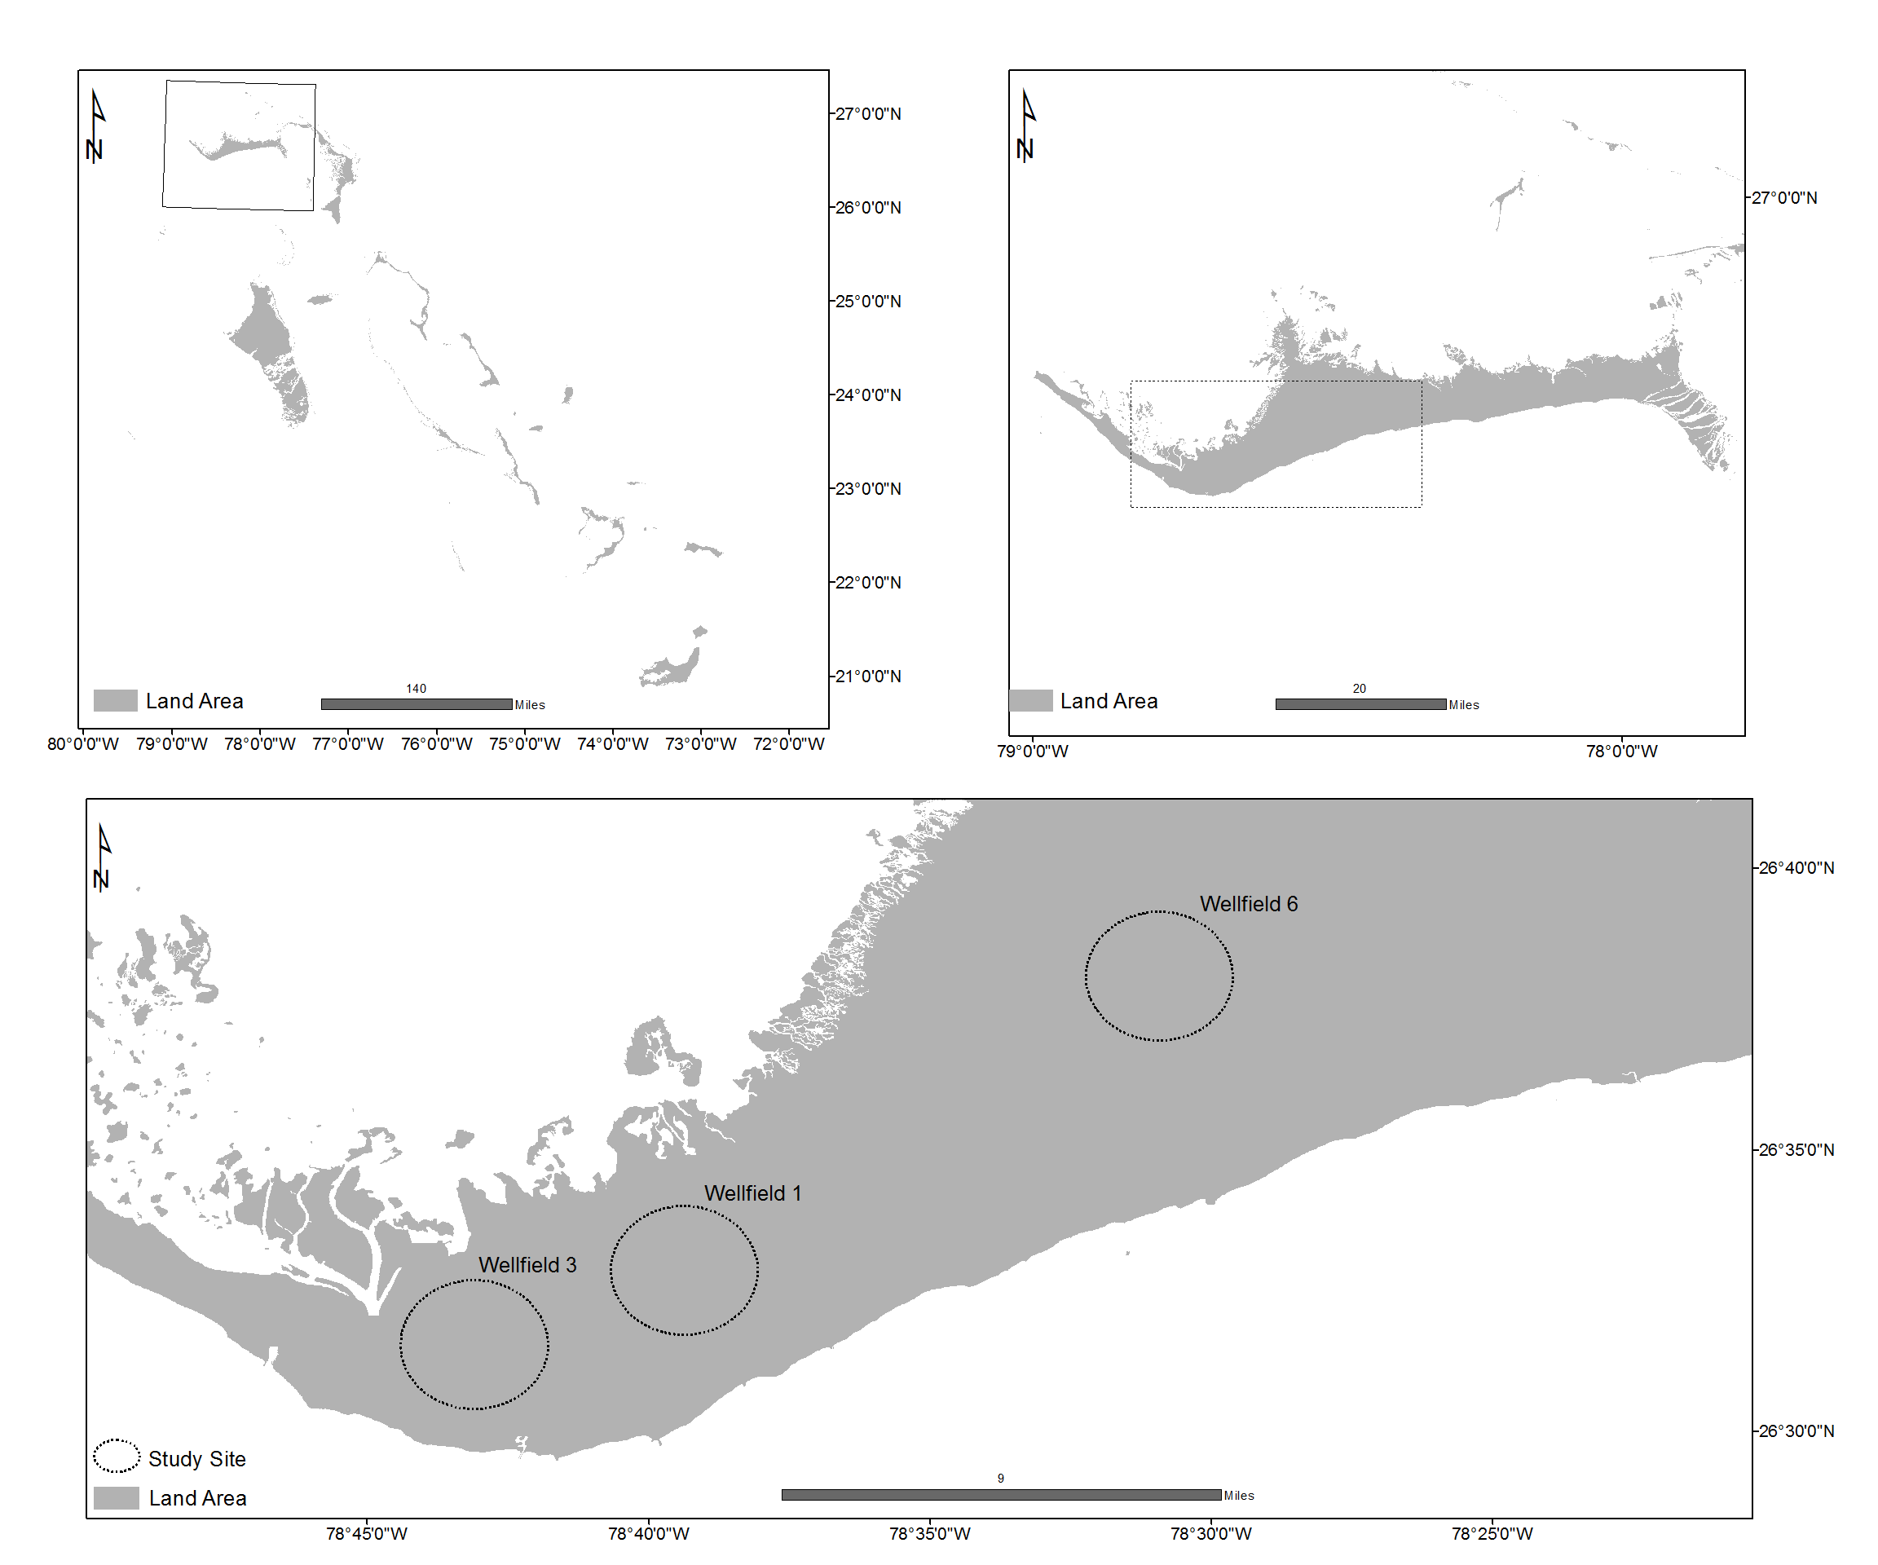

Figure 2. Map of study site in western Grand Bahama. a) The island of Grand Bahama in the archipelago of The Bahamas (location of Inset b marked by the rectangle); b) The island of Grand Bahama (inset c shown in the rectangle); and c) Locations of Wellfield 1 and Wellfield 6 study sites in western Grand Bahama.

3. Methods: Post-Hurricane Dorian Assessments

3.1 Humanitarian efforts and assessments led by IsraAID

One day after the passing of Hurricane Dorian, the Israel Forum for International Humanitarian Aid (IsraAID) dispatched an emergency response team to The Bahamas on September 5, 2019. The team launched a rapid needs assessment to identify areas for intervention. IsraAID and local partners determined a focus of 3 key sectors: relief item distribution, psychosocial support, and water, sanitation, and hygiene (WASH). IsraAID’s efforts pertaining to WASH consisted of two main activities: (i) a 2-week rapid groundwater assessment and (ii) a 1-year WASH Programme.

IsraAID, in partnership with Israel’s Agency for International Development Cooperation (MASHAV) in the Ministry of Foreign Affairs and the Israel Water Authority, facilitated a local rapid groundwater assessment led by Israel’s Chief Hydrologist. The objective of the rapid water assessment was to conduct field visits to assess water resources Post-Hurricane Dorian and to provide recommendations for a long-term water management strategy. Field visits were conducted in the islands of Grand Bahama and Abaco from October 23-29, 2019. The field visits included a groundwater survey of the major wellfields operated by the local water utilities on both islands and two blue holes in Grand Bahama (i.e., Owl’s and Ben’s). The following water quality parameters were measured: electrical conductivity (with profiles taken where possible), pH, and oxidation reduction potential (ORP). A major recommendation from the rapid assessment was the establishment of a WASH Programme.

IsraAID’s WASH Programme ran from September 2020 to August 2021. The WASH Programme consisted of two components: (i) a sustainable groundwater management project (SGMP) with four phases and (ii) a community outreach initiative. Phase 1 was a groundwater survey, which included geospatial and GPS mapping of water infrastructure (e.g., pumping and observation wells, pumping stations, etc.), in-situ water quality testing, and data collection and analysis for Grand Bahama and Abaco. Water quality parameters (conductivity, pH, temperature, salinity, and total dissolved solids [TDS]) were measured using YSI Quatro Plus meters, and the depth to the water table and bottom of wells were measured using water level meters. All data that were collected were uploaded to an open-source platform called mWater. The results of the groundwater survey informed the placement of 16 new observation wells (8 on each island) that ranged from 30 ft to 110 ft in depth.

For insight into the long-term changes to the freshwater lenses, 4 observation wells were placed to penetrate the brackish zone (i.e., sentinel wells) while the remaining wells were contained in the freshwater lens and proximal to production wells. Each observation well was designed and constructed for extreme weather and equipped with a Solinst Levelogger LTC 5 (a multi-parameter water quality sensor) that would measure temperature, conductivity, and static water level on an hourly basis. Due to the logistical difficulties in manually retrieving well data on Abaco, Solinst LevelSenders were also installed as telemetry devices that would send daily email reports with all measurements via communication networks. The installation of these wells and devices was the objective of Phase 2 – establishing a groundwater monitoring network. Phase 3 involved a water management training programme for personnel from both water utilities (i.e., WSC and GBUC) and other local stakeholders as a way of building local capacity. The training had theoretical and practical aspects, covering 10 topics that included basic hydrogeology, best practices for well data collection and reporting, and climate change, resilience, and alternative water supplies and treatment technologies. Phase 4, the final phase, consisted of data interpretation and data management. Databases were developed for both water utilities for the continued monitoring, organizing, and storing. The aim of this phase was to help the authorities manage the water resources in a sustainable manner.

3.2 Initial assessments post-Hurricane Dorian by UNESCO-IHP and government

On September 8, 2019, in the immediate aftermath of Hurricane Dorian, a team of professionals representing United Nations Educational, Scientific and Cultural Organization – Intergovernmental Hydrologic Programme (UNESCO-IHP), the Water and Sewerage Corporation (WSC), and Bahamas Power and Light (BPL) visited Grand Bahama to assess damage, in collaboration with GBUC. No water resource assessments or measurements were conducted at this time, as the island was still flooded from the hurricane. This visit allowed personnel to conduct visual observations and assess the damage to mobilize and allocate the required funding.

An expedited groundwater quality assessment was carried out by representatives of University of Brasilia in October 2019 one month post-Hurricane Dorian to assess the impact of Dorian’s storm surge on the quality of the freshwater lens of selected wells of Wellfields 1 and 6. During this evaluation, salinity, TDS, and electrical conductivity were measured in groundwater from these wells.

3.2 Follow up assessments post-Hurricane Dorian by university researchers

Recognizing the need to collect time sensitive data pertaining to the storm-induced saltwater intrusion on the island of Grand Bahama, a team of scientists from California State University, Sacramento and Florida Institute of Technology, in collaboration with local engineers and faculty from the University of the Bahamas, conducted a series of field campaigns to assess groundwater and soil salinity on various locations of the island between February and November 2020.

On February 2020, an initial field campaign was conducted, which included the sampling of thirty-eight wells across Wellfields 1, 3-4, and 6. The parameters sampled included electrical conductivity, TDS, salinity and temperature. After this initial survey, groundwater samples were collected on a biweekly basis at six wells in Wellfield 1, three wells in Wellfield 3 and 4 and nine wells at Wellfield 6. Sampling was conducted using a REED Instrument SD-4307 SD Series Conductivity/TDS/Salinity Datalogger. Groundwater levels were collected in four wells in Wellfield 1, seven in Wellfield 2 and two in Wellfield 6 using a Solinst 102 Water Level Meter.

Regarding soil sampling, eleven surficial samples were collected four times (May, June, August and November 2020) and one core profile once (May 2020), to determine the distribution of salt within the soil profile and in the surficial soil sediments. Soil samples were taken at depths of 10-15 cm 4 to 6 inches. The soil analysis was conducted by faculty and undergraduate students at the University of the Bahamas Soils Laboratory. The samples were crushed, sieved and prepared for testing using the saturated paste method.

3.3 Follow-up assessments two years post-Hurricane Dorian by university researchers and practitioners

A final field campaign occurred in January 2022 to investigate the recovery of the wellfields more than two years post-Hurricane Dorian. During this site visit a team of researchers from University of The Bahamas, the Forestry Unit, and University of Brasilia evaluated groundwater, soils, and forests. Soil and water measurements were collected on 24 January 2022 in W1 and 25 January 2022 in W6. Water assessments consisted of sampling four groundwater wells in Wellfield 1 and seven groundwater wells in Wellfield 6. Groundwater quality was measured with a Hanna Multiparameter Water Quality meter, model HI98914. Parameters measured included salinity, electrical conductivity, dissolved oxygen, temperature, pH, and TDS.

Soil sampling in January 2022 consisted of sampling four locations at W1 (11 electrical conductivity samples and 13 soil moisture samples) and 3 locations at W6 (18 electrical conductivity samples and 10 soil moisture samples). At each site, the soil O horizon was cleared away, and a stainless-steel shovel was used to dig a small hole down to bedrock. A plastic auger was used to create a hole to insert soil probes vertically and horizontally; samples for each site were taken in an area with ~0.5 m radius. Electrical conductivity (EC) and temperature were analyzed using a Hanna HI98331 Groline Direct Soil Conductivity and Temperature Meter, calibrated using HI7031 solution prior to field use (accuracy @25degC: +/-50 µS/cm, +/- 1°C; resolution: 1µS/cm, 0.1°C). Soil moisture (SM) was analyzed using the Extech MO750 Soil Moisture Meter (accuracy: +/-5% @23+/-5°C; resolution: 0.1%). Soil color was described for each site using a Munsell Soil Color chart under daylight conditions. Hydraulic conductivity was assessed with a single ring infiltrometer (Youngs, 1987).

Forest assessments consisted of evaluating pine tree mortality and plant species abundance within sample plots at each wellfield. Ten-meter diameter circular plots were used. The center point of each plot was selected 20 m perpendicular to the well site. Each plot was divided into four quadrants using a 5 m radius to each of the cardinal points. In each quadrant, pine trees with crown branches attached and a diameter of 5 cm and greater were measured. For each pine tree, diameter at breast height (1.3 m from the soil surface), tree height, and condition (dead or alive) were recorded. In each quadrant, the 10 most frequent plant species were also recorded and counted. Data analysis included the determination of available pinewood and the relative abundance of species for each wellfield.

3.4 Evaluation for Managed Aquifer Recharge by university researchers

In 2021 a study was initiated by a team from the Technical University of Munich to investigate the potential of managed aquifer recharge (MAR) to provide drinking water and to mitigate saltwater intrusion to the freshwater lenses of Wellfield 6. MAR is the intentional and monitored recharge of water from surface water, rain, or stormwater into an aquifer. The overall goal of MAR is to increase groundwater levels to store water for a time of need or to improve water quality of groundwater due to mixing with infiltrating water (Dillon, 2005). To identify potential suitable locations for MAR on Grand Bahama, a methodology was developed which includes hydrological, hydrogeological and geological investigations based on existing data. Several water sources for recharging water under a MAR scheme were investigated.

4. Results and Discussion

4.1 Groundwater

From the 2-week rapid water assessment conducted by IsraAID, the TDS of supplied water in Grand Bahama was approximately 5000 ppm, more than 5-times more than the maximum recommendations of the World Health Organization (World Health Organization [WHO], 2017). In McClean’s Town, Grand Bahama, specific conductivity of groundwater was approximately 2100 µS/cm, whereas in Marsh Harbour (Abaco) salinity was approximately 1600 µS/cm. From the extensive groundwater survey conducted in Phase 1 in the following year, the impacts to the freshwater lenses on Abaco were determined to be less severe than on Grand Bahama, and recovery to Pre-Dorian conditions in most of the wellfields was relatively rapid. Data from the observation and sentinel wells cannot be provided as values had an extremely wide range, likely due to data loggers being set too deep in several wells. Loggers were raised to more suitable depths after wells were profiled. This action would allow for more accurate water quality assessments to be carried out in the future.

From the initial post-Hurricane Dorian assessments in October 2019, salinity, TDS, and conductivity levels were elevated in three wells from Wellfield 1 and three wells from Wellfield 6. The highest values for all three parameters were observed at Wellfield 6. An initial map of TDS (in ppm) based on the data collected during the field campaign beginning in February 2020 is shown in Figure 3. As seen from the figure, TDS levels were elevated, well above the drinking water standards with the highest value occurring at Wellfield 6 (7490 ppm). Out of these 38 wells, 16 were then selected for long-term monitoring. The data collected during the time period February to November 2020 indicate a very slow recovery process of the freshwater lens system (Figure 4). A year after Hurricane Dorian, elevated levels of salinity were still detected on both the groundwater and soils on most locations on the island, despite the fact that it was a relatively wet year (Figure 5), with significant precipitation levels. More specifically, the maximum TDS concentrations measured are 845 ppm, 976 ppm and 2510 ppm in Wellfields 1, 3-4 and 6, respectively.

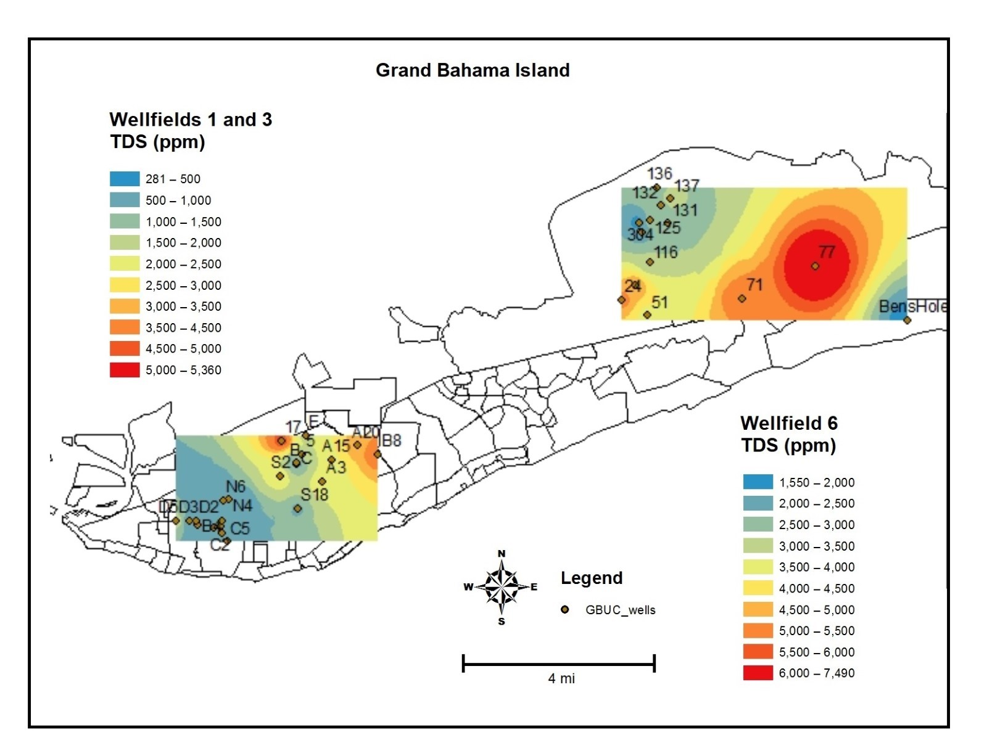
Figure 3: TDS concentrations (ppm) measured in groundwater in wellfields 1, 3 and 6 in February 2020

Figure 4. Comparison of Electrical Conductivity (4a), Total Dissolved Solids (4b), and Salinity (4c) in Wellfields 1, 3, and 6 in Grand Bahama Island from 12 February 2020 through 25 January 2022.

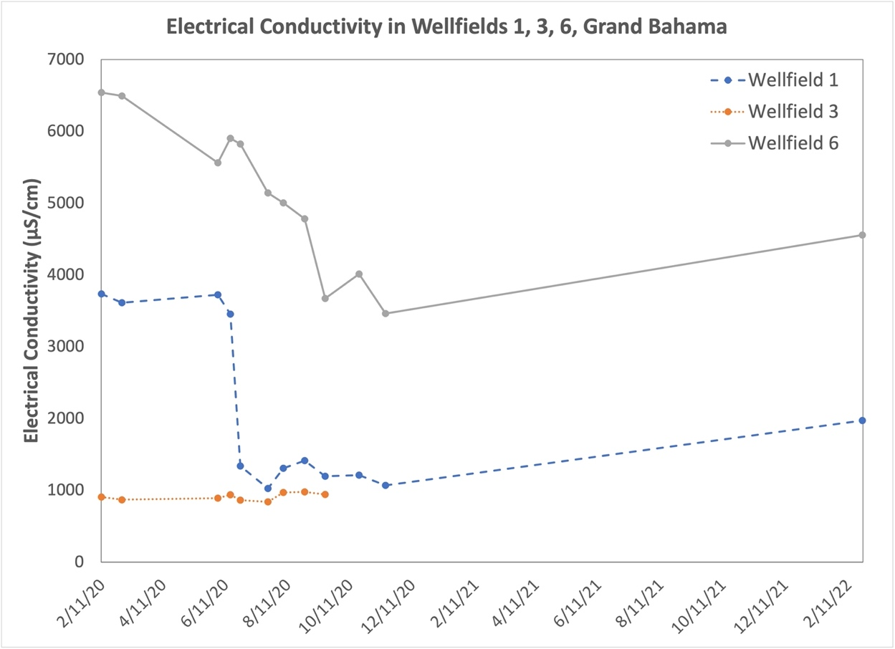

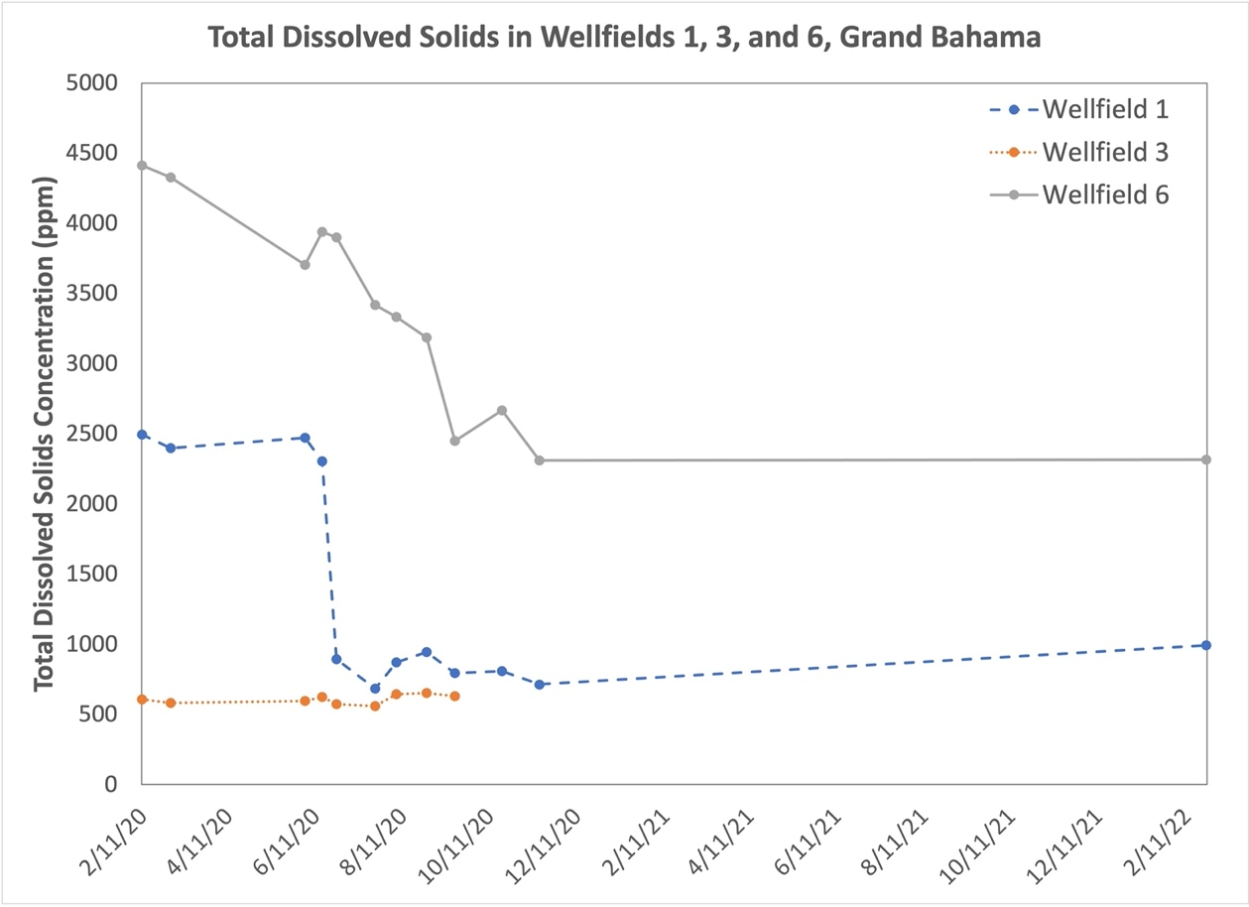

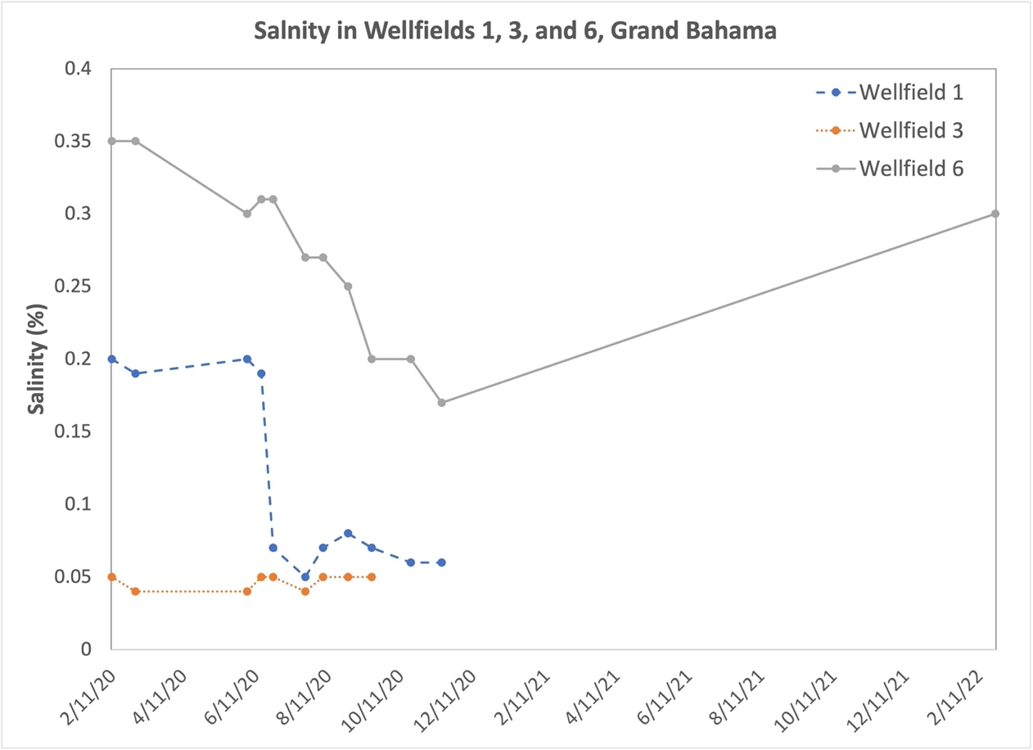

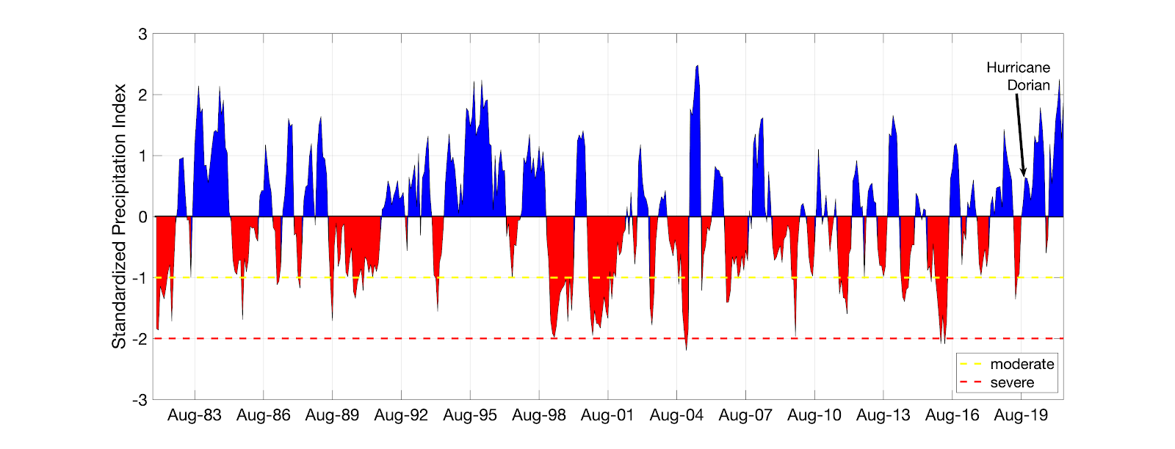
Figure 5. Six-month Standardized Precipitation Index (SPI) for Grand Bahamas island during Jan 1981 to Oct 2020. SPI was derived based on ERA5 atmospheric reanalysis data.

In the most recent assessment in January 2022, observations of TDS had declined to an average of 2316 ppm in W6 and 993 in W1. W6 continues to exceed WHO drinking water standards (1000 ppm) (WHO, 2017). Electrical conductivity levels in W6 were still elevated (2757 – 6326 µS/cm) with W1 exhibiting moderately elevated levels (1657 – 2227 µS/cm). While concentrations have declined for TDS two years following the previous assessment, both electrical conductivity and salinity have increased since the previous sampling campaign. The high elevations that the wellfields exhibit suggest that the wellfield will take many years to recover.

4.2 Soils

Soil analyses conducted during the 8-month period from March 2020 to November 2020 revealed that after four rounds of sampling, there was no evidence of salinity clearance for any of the sample points (Table 1). Two years post-Hurricane Dorian, high electrical conductivity (640-3190 µS/cm) and soil moisture (22.6-25.4%) were measured from the silt crust on the forest road shoulder (Table 1, Figure 5), and likely due to poor drainage through the hard limestone track beneath. These values should not be seen as representative of the wider forest area, though, as soil electrical conductivity is moderate in W1 (30-400 µS/cm, Table 1) and in a similar range as W6 (10-250 µS/cm; excluding elevated road shoulder data, Table 1) and when considering probe accuracy (+/-50 µS/cm), and indicative of a reduction in salinity as compared to two years previously. The silt crust measured in 2022 is thus not deemed a major contributor to the salinity of groundwater on Grand Bahama Island. The lower mean electrical conductivity (204 µS/cm, Figure 5) of the silt crust measured in the forest is likely due to leaching through organics observed below. The soil moisture readings from W1 (0.7-16.4%) are comparable to those in W6 (7.6-14.4%, excluding elevated road shoulder data), and when considering the 5% probe accuracy. The interrelation of electrical conductivity and soil moisture is indicated by positive correlation (r² 0.74), as also found by Zhang et al. (2019).

Table 1. Electrical conductivity (EC), temperature (T), Salinity, pH, and total dissolved solids (TDS) of soils in Wellfields 1, 3, and 6, Grand Bahama Island, sampled from 7 March 2020 through 25 January 2022.

Wellfield | Number of Samples | Date | EC soil (μS/cm) range | EC soil (μS/cm) mean | T (°C) soil range | Depth (cm) range | Salinity (%) | pH | TDS(ppm)
1 | - | 7-Mar-20 | 582-1771 | 924 | - | 0-762 | - | - | -
 | 2 | 29-May-20 | 1435-1876 | 1655.5 | 29.5 - 29.7 | 0-10 | 0.085 | 7.92 | 1103
 | 3 | 26-Jun-20 | 1048-1672 | 1304 | 29.9-31.1 | - | 0.067 | 7.96 | 868.3
 | 3 | 7-Aug-20 | 878-1085 | 1002 | 26.8-27.3 | - | 0.057 | 7.96 | 668
 | 2 | 13-Nov-20 | 498-1112 | 805 | 19.4-20.7 | - | 0.045 | 7.18 | 535.5
 | 1 | 15-Nov-20 | - | 0.6 | 20.7 | - | 0.030 | 7.42 | 388
 | 11 | 24-Jan-22 | 30-400 | 183.7 | 20.8-23.8 | 4-26 | - | - | -
3 | - | 29-May-20 | - | - | - | 0-10 | - | - | -
 | 2 | 29-May-20 | 1066-1594 | 1.33 | 29.5 - 29.7 |  | 0.065 | 7.89 | 886
 | 2 | 26-Jun-20 | 1015-1754 | 1384.5 | - |  | 0.070 | 7.92 | 922
 | 2 | 7-Aug-20 | 1019-1464 | 1241.5 | 27.1-27.3 |  | 0.065 | 7.88 | 828.5
 | 3 | 16-Nov-20 | 510-767 | 0.659 | 19.1-20.7 |  | 0.035 | 7.23 | 403.5
6 | - | 29-May-20 | - | - | - | 0-10 | - | - | -
 | 5 | 29-May-20 | 852-1718 | 1402 | 29.5 - 29.7 | - | 0.07 | 8.09 | 933.6
 | 6 | 26-Jun-20 | 810-1921 | 1151.3 | 19.7-31.0 | - | 0.06 | 7.83 | 766.5
 | 7 | 7-Aug-20 | 718-1828 | 1.3 | 26.9-27.3 | - | 0.07 | 7.99 | 850.1
 | 18 | 25-Jan-22 | 10-3190 | 775 | 17.8-23.2 | 2-12 | - | - | -

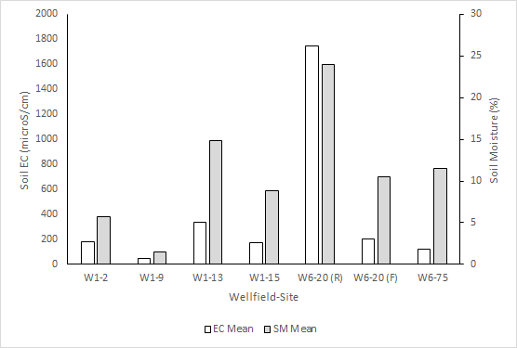
Figure 5. Mean soil electrical conductivity (EC) and soil moisture (SM) measured at W1 and W6, Grand Bahama Island, on 24 and 25 January 2022, respectively. Wellfield 6-Site 20 was differentiated into the silt crust analyzed on the road (R) and forest (F).

4.3 Forests

The potential harvestable timber volume was greater for W1 (combined live and dead trees, 13.68 m³) than for W6 (dead trees, 4.93 m³). According to Forest2Market Inc. (a southern USA timber sales tracking company, www.forest2market.com), the weighted average price for timber in the southern states was $956 per 1000 board feet, in 2021. Therefore, the combined value of timber for the wellfields in 2021 was US$7,537 (Table 2).

Table 2. Harvestable pine tree volume and basal area per tree in Wellfields 1 and 6.

Wellfield | Condition | Number of trees | Total basal area per tree (m²) | Total tree volume (m³) | Board Feet (‘1000) | Value (USD)
1 | Alive | 42 | 1.12 | 11.60 | 4912 | 4695.87
 | Dead | 8 | 0.17 | 2.09 | 885 | 846.06
 | Sum | 50 | 1.29 | 13.68 | 5797 | 5541.93
6 | Dead | 35 | 0.48 | 4.93 | 2088 | 1995.17
 | Total Timber | 85 | 1.77 | 18.61 | 7884 | 7537.10

Thirty-seven different plant species were found during the sampling campaign in January, 26 species in W1 and 31 species in W6, (Table 3). W1 had a higher Shannon diversity index (3.00) than W6 (1.18), with the top 10 most abundant species in each field accounting for 77% and 81%, respectively. The dominant species (more than 10% relative abundance) made up for more than 35% of the species in each wellfield (Table 3). In W1, three species were the most abundant: Metopium toxiferum (15%), Adiantum capillus-veneris (14%) and Coccothrinax argentata (11%). Notably, in W6 only two species, Coccothrinax argentata and Metopium toxiferum at 18% each, were the most abundant (Table 3). Even though W6 had a greater number of species, the presence of the dominant top 10 species reduced the overall diversity within the sampled plots.

Table 3. Plant species abundance and diversity in W1 and W6 in January 2022.
Botanical Species | Common Name | W1 |  | W6
 |  | Number of individuals (n) | Relative abundance | Number of individuals (n) | Relative abundance
Coccothrinax argentata | Silver thatch palm | 202 | 0.11 | 605 | 0.18
Metopium toxiferum | Poisonwood | 270 | 0.15 | 601 | 0.18
Byrsonima lucida | Guanaberry | 44 | 0.02 | 257 | 0.08
Smilax havanensis | Chaney Briar | 58 | 0.03 | 242 | 0.07
Myrica cerifera | Wax Myrtle | 27 | 0.02 | 234 | 0.07
Myrsine floridana | Colic Wood | 36 | 0.02 | 197 | 0.06
Pinus caribaea var. bahamensis | Bahamian pIne | 149 | 0.08 | 190 | 0.06
Diospyros crassinervis | Featherbed | 72 | 0.04 | 163 | 0.05
Ernodea littoralis | Golden Creeper | 20 | 0.01 | 125 | 0.04
Adiantum capillus-veneris | Maiden Hair | 243 | 0.14 | 96 | 0.03
Psychotria ligustrifolia | Smooth Wild Coffee | 93 | 0.05 | 80 | 0.02
Randia aculeata | Box Briar | 38 | 0.02 | 76 | 0.02
Tabebuia bahamensis | Five finger | 119 | 0.07 | 66 | 0.02
Morinda royoc | Wild Mulberry | 11 | 0.01 | 60 | 0.02
Chrysobalanus icaco | Coco plum | 0 | 0.00 | 44 | 0.01
Euphorbia prostrata | Lay Flat Spurge | 64 | 0.04 | 36 | 0.01
Fern (unidentified) |  | 0 | 0.00 | 36 | 0.01
Agave bahamana | Bahama Century Plant | 1 | 0.00 | 33 | 0.01
Rhynchospora floridensis | White Top, White-headed Rush | 0 | 0.00 | 33 | 0.01
Caesalpinia bahamensis | Bahama Brasiletto | 109 | 0.06 | 31 | 0.01
Heliotropium angiospermum | Rooster Comb | 15 | 0.01 | 30 | 0.01
Turnera ulmifolia | Bahamian Buttercup | 0 | 0.00 | 24 | 0.01
Stenaria nigricans | Star violet | 0 | 0.00 | 21 | 0.01
Trema lamarckiana | Pain-in-Back | 0 | 0.00 | 15 | 0.00
Sideroxylon salicifolium | Willow Bustic | 0 | 0.00 | 12 | 0.00
unknown |  | 0 | 0.00 | 12 | 0.00
Piscidia piscipula | Jamaican Dogwood | 0 | 0.00 | 7 | 0.00
Pteridium aquilinum | Bracken Fern | 0 | 0.00 | 7 | 0.00
Bourreria succulenta | Strong Back | 13 | 0.01 | 1 | 0.00
Pecluma plumula | Comb Fern | 0 | 0.00 | 1 | 0.00
Petitia domingensis | Bastard Stopper | 0 | 0.00 | 1 | 0.00
Leucaena leucocephala | Jumbey | 55 | 0.03 | 0 | 0.00
Zamia pumila | Coontie, Bay Rush | 53 | 0.03 | 0 | 0.00
Coccoloba diversifolia | Pigeon Plum | 48 | 0.03 | 0 | 0.00
Tetrazygia bicolor | Wild Guava | 29 | 0.02 | 0 | 0.00
Lantana x bahamensis | Wild Sage | 11 | 0.01 | 0 | 0.00
Chiococca alba | Snow Berry | 4 | 0.00 | 0 | 0.00
Total number of individuals (N) |  | 1784 | 1 | 3336 | 1.00
Shannon's Diversity Index |  | 3.00 |  | 1.18
Number of species per wellfield |  | 26 |  | 31
Total number of species |  | 37

5. Management Strategies and Research Opportunities

5.1 Groundwater Restoration

Due to the extensive flooding at W6, this wellfield is anticipated to take longer to recover than W1, which is already showing signs of improvement. Although W6 salinity and TDS concentrations have decreased two years post-Hurricane Dorian from initial values, the concentrations remain very elevated and exceed drinking water standards.

Evaluation of Managed Aquifer Recharge

Managed Aquifer Recharge (MAR) could be a potential method for diluting salt concentrations in groundwater and for establishing hydraulic conditions that preserve and enhance freshwater lenses in the subsurface. Rain water was identified as the most promising potential source for MAR. Based on data collected in Freeport from the Bahamas Meteorological Department between 2012 and 2020, a mean annual rainfall of 1600 mm was calculated by Klausner (2022). Surface water is very limited on the island, as low terrain and natural permeability of the limestone does not allow the formation of larger surface water bodies (ICF, 2001). Furthermore, wastewater is not collected in a centralized wastewater treatment system to consider it as a water source in sufficient quantity nor quality.

Many of the available aquifers on the island could potentially be suitable for water storage due to their high hydraulic conductivity and storativity. Nevertheless, restrictions exist for the location of potential MAR schemes, such as flood-proof design in Wellfield 6 because of low terrain levels. Saltwater intrusion into Wellfield 6 could be mitigated by recharging freshwater with injection wells installed at locations that are safe from floods. Freshwater sources could be rainwater or desalinated water obtained from reverse osmosis plants. Neither the necessary quantity of freshwater nor the timeframe to dilute the brackish water in the aquifers of W6 has been estimated, to date. Numerical modelling studies could be conducted for estimating water quantities and thus predicting the feasibility of such approaches. Additional geophysical, groundwater level and salinity level measurements should be carried out to reach prediction integrity with the models.

Because of the flooding potential, we focused the investigation of potential suitable locations for MAR on areas of the island with higher laying terrain. The Intergovernmental Panel on Climate Change [IPCC] (2007) reported that Grand Bahama is particularly threatened by climate change effects with sea level rise due to its low terrain levels (60% of the island have elevations lower than 1 m.a.s.l.). The areas around Wellfields 1, 3, and 4 were identified as potentially suitable. In a study by Little et al. (1977) high evapotranspiration rates on the island of 75% were identified. Due to the high evapotranspiration losses, suitable MAR types should enable comparatively rapid groundwater recharge. Since rainwater would be the main water source for MAR, an urban MAR method is recommended, potentially also including collected runoff water from roofs and streets, if a sufficient water quality can be assured (Page et al., 2018). To identify the full potential of urban MAR methods on Grand Bahama, further hydrogeological and geophysical investigations are recommended to identify the flow regime in the elevated terrain of Grand Bahama. This would allow the identification of suitable locations for recharge schemes. Particular emphasis should also be put on water quality implications from the recharging water to the wellfields.

Groundwater adaptation strategies

Strategies should be developed for sustaining future independent and sustainable water supply on the island of Grand Bahama. The Bahamas is particularly vulnerable to the effects of climate change, such as extreme weather events with tropical storms and sea level rise (IPCC, 2007). Water management is a key element in the social and economic development on the island (Cashman et al., 2010). A potential option to counteract negative effects of climate change on water resources on Grand Bahama could be the diversification of water sources to reduce demand on the freshwater lens. A combination of drinking water sources from groundwater and desalinated water, using reverse osmosis, are already available to date. Furthermore, a wastewater treatment system could be installed on the island, and treated wastewater could be a potential source of water supply. Radcliff and Page (2020) report that climate change effects, such as droughts, have been a driving factor to implement wastewater treatment and desalination plants in Australia.

Reducing demand of the freshwater lens is an important adaptation strategy. Water policies for water reduction, such as restricting the use of private pools or garden watering could be passed to ensure conservation of freshwater resources. Water leakages from the water supply system in Grand Bahama are estimated to account for 30-40% of water losses. Therefore, renovation of the water supply system could decrease water demand significantly and promote a sustainable drinking water supply on the island.

Increasing storage in the freshwater lens is also a critical adaptation measure to address climate change. MAR could be a cost-efficient potential solution to supply water to the island and store water for future demand in comparison to water treatment (Damigos et al., 2016). Diamond and Melesse (2016) evaluated the potential for MAR with runoff harvesting from roads on the neighboring island New Providence. Like on Grand Bahama, a drainage well system exists for the prevention of road flooding. Due to the lack of water treatment, road runoff could pollute the aquifer with contaminants (e.g., tire wear). The existing wells could be renovated by drilling additional wells and adding filters for water purification. Extension of the existing drainage well system on Grand Bahamas as well as renovation for water quality treatment, could be an additional source of water supply for Grand Bahama.

5.2 Alternative Potable Water Sources

The feasibility of long-term restoration of the aquifer is challenged by the costs associated with these endeavors. MAR schemes have the potential to be cost prohibitive, and installation of a reverse osmosis plant would add significantly to the annual costs of GBUC. In addition to restoring the freshwater lens, alternative methods exist for increasing water supply on the island.

Desalination

Following the inundation of the wellfields, GBUC began operating a portable desalination system on saline water pumped from W1 to ensure potability of the water being pumped to residences. To sustain desalination efforts long-term at a rate that is sufficient to meet demand of the island, GBUC is currently partnering with outside organizations to build a reverse osmosis plant to provide potable water for the island. Desalination provides valuable drinking water sources for small islands and other areas that are threatened by lack of fresh water. However, reverse osmosis plants are very energy intensive and contribute to greenhouse gas emissions (Schunke et al. 2020). As small islands are facing the effects of climate change, such as Grand Bahama with Hurricane Dorian, reliance on reverse osmosis plants can negatively impact long term sustainability. Alternative methods are also important to consider, to reduce reliance on fossil fuels, to minimize contribution to greenhouse gas emissions, and to diversify sources to avoid over-reliance on any one method.

Ocean Thermal Energy Conversion

In The Bahamas, sustainable development is challenged by energy production and water supply, as is typical of small island nations. Ocean Thermal Energy Conversion (OTEC) is a technique that can produce both energy and freshwater, enhancing the potential for the country to become more resilient against climate change (Fujita et al. 2012). The Bahamas exhibits inverted geothermal conditions in subsurface waters, which is ideal for the development of OTEC. In larger continental countries, geothermal conditions typically get warmer with depth, whereas in The Bahamas the high exchange with ocean water results in inverted conditions where water gets cooler with depth.

In the deep subsurface of The Bahamas, the temperature and salinity of the groundwater indicate a high exchange between subsurface and ocean waters. Additionally, the high transmissivity and hydraulic conductivity of Lucayan limestone promote the abstraction of groundwater and return of water flows. OTEC could provide an opportunity to extract deeper saline waters for conversion to fresh drinking water, reducing demand of the fragile freshwater lens, while also providing energy and reducing overall fossil fuel reliance.

Rainwater harvesting

Rainwater harvesting is a sustainable method to further promote water security on Grand Bahama. Rainwater collection involves storing precipitation through catchments and proper storage of water, instead of allowing it to run off (Helmreich & Horn, 2009). The Bahamas has a subtropical climate where precipitation is distributed throughout the year that is conducive to rainwater harvesting. The historical method of water supply in The Bahamas was rainwater harvesting from individual roofs and storage in tanks. This method still plays a role on smaller islands, especially in the Southern Bahamas (Whitaker & Smart, 1997), but overall only around 3% of water supply is sourced from rainwater harvesting in the Bahamas (USACE, 2004)

Rainwater harvesting is a common practice throughout the Caribbean. For example, Barbados, Grenada, Antigua and Barbuda implement this practice (Ekwue, 2010), and installations of rain catchment systems of a certain size are required when building a new house in the Turks and Caicos (Whitaker & Smart, 1997). Investment and research opportunities exist in the field of rainwater harvesting, especially for small island development states, where it is a more suitable method. Harvesting decreases the demand on groundwater resources while providing avenues to educate citizens in water conservation. As stronger storms are becoming more prevalent, diversifying water resources is imperative to ensure water is available in dire circumstances. Grand Bahama has the land capacity to facilitate large rainwater storage facilities and through encouraging harvesting by residents, implementation can be successful.

5.3 Soils

The silt crust will form an event layer and partially breakdown through natural weathering into the ground beneath, adding nutrients to the soil. The electrical conductivity of the soils should be monitored periodically to better understand recovery times on Grand Bahama Island. Keim et al. (2019) measured salinity in soils and sediments affected by storm surge flooding by Hurricane Katrina in Louisiana, USA, and found elevated values 11 years after the event and estimated recovery rates to pre-hurricane salinity to be at least two decades. As electrical conductivity measurements on Grand Bahama Island are moderate in 2022 the recovery time should be shorter than in Louisiana, although it will be affected by any future flooding events.

5.4 Forests

The absence of mature pine trees in Wellfield 6 was not unexpected, as Hurricane Dorian settled over the eastern part of Grand Bahama for several hours. The substantial storm surges inundated the region bringing with it hypersaline conditions. Pinus caribaea var. bahamensis does not germinate under saline conditions and requires a slightly acidic soil pH to grow (Hamilton et al., 1993). However, the volume of wood available had the potential to be harvested soon after the storm for use as treated lumber or wood pulp. One major limitation is that the cost to remove the timber would have outweighed the value of timber sales.

W1 had greater plant diversity and is located in an area that was not as heavily impacted by Hurricane Dorian. The healthy appearance and presence of actively growing pine trees suggest that the undamaged landscape in W1 has the potential to undergo natural regeneration at a fast rate and maintain a range of species in relatively even numbers. However, W6 had greater numbers of rapid-growing, resilient species like Poisonwood and Silver Thatch Palm, which were the most dominant species. The presence of pine seedlings in W6 also indicates that natural pine regeneration is occurring, which suggests that the salinity in the soil water is low enough to allow for seed germination and plant development. Overall, W6 had a dry, damaged appearance with several woody shrubs and low, fast-growing, herbaceous species.

The current species composition in both wellfield sites suggests that the pine forests are showing signs of recovery and are, therefore, quite resilient. Since these data were collected more than two years after the catastrophic storm, it can be deduced that once unfavorable environmental conditions are reduced, the forested areas will be able to regenerate and recover. The more forested areas show greater signs of regeneration, while the more open areas with no pine trees show slower rates of recovery.

Conclusions

Weather and climate are arguably the main drivers of freshwater resources. To develop a resilient water supply system, water resource managers must anticipate and account for changes in climatic variability and extremes. The scientific community and agencies such as US National Atmospheric and Oceanic Administration and National Aeronautics and Space Administration have developed tools and services to help communities increase their capacity building on resilience to climate change. As an example, the North American Multi-Model Ensemble (Becker et al. 2022) provides 12-month forecasts of precipitation and other atmospheric variables at global scale. Such information, if properly utilized, can inform water managers and help them optimize some of the strategies mentioned previously (e.g., rainwater harvesting). Furthermore, analysis of current state-of-art climate projections from CMIP6 (Eyring et al. 2016), in combination with sea level rise scenarios for climate impact assessment on the island’s water resources, is necessary to develop effective mitigation strategies. Coupling information from seasonal forecasts and climate projections with numerical groundwater models can offer a very important prediction framework that can be used for both monitoring groundwater resources and scenario analysis for future climate conditions.

To date, the quality and quantity of drinking water has not been restored to pre-Dorian levels, and the impacts to soils and forested ecosystems in western Grand Bahama are still evident. Despite elevated salinity in the wellfields for more than two years post-Hurricane Dorian, W1 is showing decreased levels and is anticipated to recover faster than W6, where the flooding was deeper and the current salinity levels are higher. While this collaborative effort summarizes research efforts in the study area, further studies quantifying fresh water and characterizing water quality, soil, and land cover in the wellfields are critical to evaluate how Grand Bahama recovers from this catastrophic event in the long term. Small islands are increasingly threatened by extreme events, such as hurricanes, and sea level rise associated with climate change, and results from Grand Bahama are important for indicating how other small islands may recover from similar events.

Acknowledgments

This project is a product of the project “Strengthening of Forests Through Groundwater Restoration” under the Bahamas Protected Areas Fund and the Caribbean Biodiversity Fund, financed by the German Federal Ministry for Economic Cooperation and Development through KfW. The authors would like to thank Andrew Curry and Cliff Bethel, who assisted with forestry data collection. Part of this material is based upon work supported by the National Science Foundation under Grant No. 2015311. The WASH Programme carried out by IsraAID was funded by The United Methodist Church (UMCOR), and additional assessments were the joint efforts of IsraAID, Israel Water Authority, and the Israeli Ministry of Foreign Affairs. Initial site assessments immediately post-Hurricane Dorian were funded by the Water & Sewerage Corporation, as well as the United Nations Educational, Scientific, and Cultural Organization – Intergovernmental Hydrologic Programme (UNESCO-IHP). A portion of this work was conducted under Research Permit #166505 through the Department of Environmental Planning and Protection in The Bahamas.

References

Avila, L.A., Stewart, S.R., Berg, R. & Hagen, A.B. (2020). National Hurricane Center Tropical Cyclone Report: Hurricane Dorian. National Atmospheric and Oceanic Administration https://www.nhc.noaa.gov/data/tcr/AL052019_Dorian.pdf
Becker, E.J., Kirtman, B.P., L’Heureux, M., Muñoz, Á.G. & Pegion, K. (2022). A Decade of the North American Multimodel Ensemble (NMME): Research, Application, and Future Directions. Bulletin of the American Meteorological Society, 103(3), E973-E995. https://doi.org/10.1175/BAMS-D-20-0327.1
Carew, J.L., & Mylroie, J.E. (1997). Geology of the Bahamas. In: Vacher, H.L., Quinn, T.M. (Eds.), Geology and hydrogeology of carbonate islands (pp. 91–139) Elsevier.
Cashman, A., Nurse, L., &John, C. (2010). Climate change in the Caribbean: The water management implications. The Journal of Environment and Development, 19, 42–67. https://doi.org/10.1177/1070496509347088
Caribbean Disaster Emergency Management Agency. (2019), September 14. Major Hurricane Dorian. Situation Report No. 13.
Cerrai, D., Yang, Q., Shen, X., Koukoula, M., & Anagnostou, E.N. (2020). Hurricane Dorian: Automated near-real-time mapping of the “unprecedented” flooding in the Bahamas using synthetic aperture radar. Natural Hazards and Earth System Sciences, 20, 1463-1469. https://doi.org/10.5194/nhess-20-1463-2020
Chaves, H. (2021). Impact assessment and management strategies for the groundwater resources of Grand Bahama. United Nations Educational, Scientific and Cultural Organization – Intergovernmental Hydrologic Programme. Final Consultancy Report. Montevideo, 28 pps.
Damigos, D., Tentes, G., Emmanouilidi, V., Strehl, C., & Selbach, J. (2016). Economic Analysis of MAR Technologies. MARSOL Demonstrating Managed Aquifer Recharge as a Solution to Water Scarcity and Drought.
Diamond, M. G., & Melesse, A. M. (2016). Water resources assessment and geographic
information system (gis)-based stormwater runoff estimates for artificial recharge
of freshwater aquifers in New Providence, Bahamas. In A. M. Melesse & W. Abtew
(Eds.), Landscape dynamics, soils and hydrological processes in varied climates (pp. 411–434). Springer International Publishing. https://doi.org/10.1007/978-3-319-18787-7_20
Dillon, P. (2005). Future management of aquifer recharge. Hydrogeology Journal, 13, 313–316. https://doi.org/10.1007/s10040-004-0413-6
Ekwue, E. I. (2010). Management of water demand in the Caribbean region: Current practices
and future needs. The West Indian Journal of Engineering, 28–35. https://64.28.139.231/eng/wije/vol3201-02_jan2010/documents/waterdemand.pdf
Eyring, V., Bony, S., Meehl, G.A., Senior, C.A., Stevens, B., Stouffer, R.J. & Taylor, K.E. (2016). Overview of the Coupled Model Intercomparison Project Phase 6 (CMIP6) experimental design and organization. Geoscientific Model Development, 9(5), 1937-1958. https://doi.org/10.5194/gmd-9-1937-2016
Fujita, R., Markham, A.C., Diaz Diaz, J.E., Martinez Garcia, J.M., Scarborough, C., Greenfield, P. Black, P. & Aguilera, S.E. (2012). Revisiting ocean thermal energy conversion. Marine Policy 36: 463-465. https://doi.org/10.1016/j.marpol.2011.05.008
Hamilton, M., Pavlik, B., Barlow, S., Manco, N., Blaise, J., Avenant, A., Hornsby, B., Hiers, K., O'Brien, J. & Sanchez, M. (2016). Caicos Pine Recovery Project National Tree Restoration Strategy: 2016-2036 restoration strategy to secure the Caicos pine for future generations. Hamilton, M.A., Manco, B.N. & Sanchez, M.D. (eds). Richmond, Surrey, UK: Royal Botanic Gardens, Kew. https://doi.org/10.13140/RG.2.1.1995.5602
Helmreich, B., & Horn, H. (2009). Opportunities in rainwater harvesting. Desalination 248, 118–124. https://doi.org/10.1016/j.desal.2008.05.046
ICF Consulting. (2001). The Bahamas national report: Integrating management of watersheds and coastal areas in small developing states of the Caribbean (The Government of The Bahamas, Office of the Prime Minister, The Bahamas Environment, Science, and Technology Commission, & ICF Consulting, Eds.). https://doi.org/10.14714/CP23.762
Intergovernmental Panel on Climate Change. (2007) Climate Change 2007: The Physical Science Basis – Summary for Policy Makers. Cambridge University Press, Cambridge, UK.
Keim, R.F., Lemon, M.G.T., & Oakman, E.C. (2019) Posthurricane salinity in an impounded coastal wetland (Bayou Sauvage, Louisiana, U.S.A.). Journal of Coastal Research, 35(5), 1003-1009. https://doi.org/10.2112/JCOASTRES-D-18-00088.1
Klausner, S. (2022). Feasibility of managed aquifer recharge on Grand Bahama. [Unpublished Master’s Thesis in Environmental Engineering]. Technical University of Munich.
Little, B. G., Buckley, D. K., Cant, R., Henry, P. W. T., Jefferiss, A., Mather, J. D., Stark, J., & Young, R. N. (1977). Land resources of The Bahamas: A summary (Land Resources Division, Ed.)
Mazzoni, N.G. (2013). Hurricane Surge Review. Davies Associates Ltd.
Mylroie, J.E., Carew, J.L. & Moore, A.I. (1995) Blue holes: Definition and genesis. Carbonates and Evaporites, 10(2), 225–233. https://doi.org/10.1007/BF03175407
Page, D., Bekele, E., Vanderzalm, J., & Sidhu, J. (2018). Managed aquifer recharge (MAR) in sustainable urban water management. Water 10, 1–16. https://doi.org/10.3390/w10030239
Radcliffe, J.C. & Page, D. (2020). Water reuse and recycling in Australia — history, current situation and future perspectives. Water Cycle, 1, 19–40. https://doi.org/10.1016/j.watcyc.2020.05.005
Schunke, A.J., Hernandez Herrera, G.A., Padhye, L. & Berry, T.-A. (2020). Energy recovery in SWRO Desalination: Current status and new possibilities. Frontiers in Sustainable Cities 2:9. https://doi.org/10.3389/frsc.2020.00009
Sealey, N.E. (2006) Bahamian Landscapes. An Introduction to the Geology and Physical Geography of The Bahamas. 3rd ed. Macmillan, London.
Turner, A. (2022). The socioeconomic impact of Hurricane Dorian on the potability of water for residents of Grand Bahama. [Unpublished Bachelor’s capstone thesis]. University of The Bahamas.
US Army Corps of Engineers. (2004). Water resources assessment of The Bahamas. US Army Corps of Engineers Mobile District & Topographic Engineering Center. https://www.sam.usace.army.mil/Portals/46/docs/military/engineering/docs/WRA/Bahamas/BAHAMAS1WRA.pdf
Vahrenkamp, V.C., Swart, P.K., & Ruiz, J. (1991). Episodic dolomitization of late Cenozoic carbonates in the Bahamas: evidence from strontium isotopes. Journal of Sedimentary Petrology, 61, 1002–1014. https://doi.org/10.1306/D4267825-2B26-11D7-8648000102C1865D
Whitaker, F. F., & Smart, P. L. (1997). Hydrogeology of the Bahamian archipelago. L. H.
Vacher & T. M. Quinn (Eds.), Developments in Sedimentology. Elsevier.
Whitaker, F.F. & Smart, P.L. (2005). Control of Hydraulic Conductivity of Bahamian Limestones. Groundwater 35, 859–868. https://doi.org/10.1111/j.1745-6584.1997.tb00154.x
World Health Organization. (2017). Guidelines for drinking-water quality: Fourth edition incorporating the addendum. Licence: CC BY-NC-SA 3.0 IGO. World Health Organization.
Youngs, E.G. (1987). Estimating hydraulic conductivity values from ring infiltrometer measurements. European Journal of Soil Science, 38(4): 623-632. https://doi.org/10.1111/j.1365-2389.1987.tb02159.x
Zhang, H., Li, Y., Meng, Y., Cao, N., Li, D., Zhou, Z., Chen, B., & Dou, F. (2019) The effects of soil moisture and salinity as functions of groundwater depth on wheat growth and yield in coastal saline soils. Journal of Integrative Agriculture, 18 (11), 2472-2482. https://doi.org/10.1016/S2095-3119(19)62713-9

