Characters With Exceptionalities Portrayed in Contemporary Canadian Children’s Books
Author
Abstract
This study examines the ways in which exceptionality is addressed in Canadian children’s literature, offering critical literacy as an avenue towards social justice. Content analysis (Berg, 2009) of 134 Canadian children’s books offers a wide scope of contemporary titles to include in classrooms.
We developed conceptual categories to explore patterns and trends through qualitative interpretive research (Seidman, 2006). Our findings include the following results:
- the exceptionalities generally correspond to their prevalence in Canada;
- genres blend and blur towards fantasy;
- characters are authentic, with real-world challenges.
As narratives that include exceptionalities become more authentic and abundant we can further appreciate diversity, fostering more inclusive schools and communities.

Résumé
Cette étude examine les façons dont exceptionnalité est traitée dans la littérature pour enfants canadiens, offrant littératie critique comme une avenue vers la justice sociale. L'analyse du contenu (Berg , 2009) de 134 livres canadiens pour enfants offre un large éventail de titres contemporains à inclure dans les salles de classe. Nous avons développé des catégories conceptuelles pour explorer des modèles et des tendances à travers la recherche d'interprétation qualitative (Seidman , 2006). Nos résultats comprennent les résultats suivants:
- les exceptionnalités correspondent généralement à leur prévalence au Canada;
- genres font fusion et brouillent vers la fantaisie;
- personnages sont authentiques, les défis du monde réel .
Comme récits qui incluent exceptionnalité deviennent plus authentique et abondante , nous pouvons continuer d'apprécier la diversité et affecter les écoles et les collectivités inclusives .

Keywords: children’s literature, critical literacy, disability studies, characters with exceptionalities, social justice

Characters With Exceptionalities Portrayed in Contemporary Canadian Children’s Books
We previously completed a comparative study of Radical Change in Canadian and American award-winning picture books, aiming to extend the scholarly debate on social justice in curriculum studies by examining representations of disability in literature for children (Author, 2013). In this updated sequel to our original work, we examine and compare the different ways in which exceptionality is addressed at various levels of Canadian children’s literature: from picture books (birth to seven years), junior novels (eight and up), and intermediate novels (eleven and up), to young adult novels (fourteen and up).
Purpose
This curriculum-related research aims to extend the scholarly debate on social justice by examining representations of disability in literature for children and youth and comparing portrayals across various age categories. Our key research questions include:
- What disabilities are portrayed in available Canadian fiction for young people? How do these portrayals vary across age categories?
- What are the trends in characterizations of disability across age categories?
- What textual messages predominate that might fuel classroom critical literacy discussions within social justice frameworks?
While other aspects of diversity such as cultural difference have been robustly included in contemporary curricular resources, differences related to disability are lacking in terms of full and authentic representation based on incidence of these disabilities in real life. Current treatment of differences related to ability can be considered as a rhizome of Radical Change (Dresang, 1999)—sprouting up in isolated areas along the main root of children’s literature, external to any comprehensive or cohesive system. Attention in this study related to characterizations that involve disabilities examines patterns and trends across various age categories, offering critical literacy as a lens through which teachers, students, researchers, and writers may interrogate textual messages towards social justice outcomes.
Theoretical and Conceptual Framework
This research, delineated from a social constructionist stance, incorporates disability studies and literary criticism and is qualitative in nature, with content analysis based on Berg’s (2009) framework. Within the context of disability studies, disability can be defined as a social construct (Sherry, 2008), contrasting with a medical model of the body wherein biological differences equate to impairment. Disability, within the Canadian education system, usually refers to a specific category of difference, such as learning disability (Smith, Polloway, Patton, Dowdy, & McIntyre, 2012). Exceptionality, within the same context, describes an individual’s strengths as well as needs (Smith, Polloway, Patton, Dowdy, & McIntyre, 2012) and for this reason is becoming a preferred term. Thus, in this article we use exceptionality as a general descriptor for those with diverse learning and other needs, and disability for a particular condition.
Research on classic fiction involving characters with exceptionalities has identified a trend that these characters are either cured or killed during the course of a story, a tendency that suggests authors have not been able to imagine a future for someone with an exceptionality. While this tendency has clearly changed in fiction for young people (Author, 2015), Radical Change (Dresang, 1999) offers an illuminative way to conceptualize the changes yet to come in children’s literature regarding iterations of ability that appear in new textual forms and formats, new perspectives, and shifted boundaries. In this study, we suggest Radical Change as a viewpoint from which to approach in educational settings an interrogation of the four dimensions of critical literacy: disruption of the commonplace, multiple viewpoints, socio-political issues, and social justice (Lewison, Flint & Van Sluys, 2002). While included in a Radical Change model of textual evolution, the nuances of the ongoing development of characters with exceptionalities require further exploration, as these nuances have clear potential for supporting critical literacy—an approach to reading that entails particular attention to content analysis. Based on previous research related to fiction that involved characters with disabilities (Author, 2010a; Dyches & Prater, 2000; Dyches, Prater, & Cramer, 2001; Greenwell, 2004; Mills, 2002; Pajka-West, 2007), this study extends previous samples in its focus on Canadian novels and picture books.
Educational Importance of the Study
Contextualized in critical literacy, previous research identifies that students can be taught to apply strategies for critical reading, including interrogations of representations of the world in classroom resources (Author, 2014). Reading instruction can be considered as a social practice that necessitates coding, establishing text-meaning, pragmatic understanding, and critical practices (Luke and Freebody, 1997). Freire’s (1983; 1991; 1998) theoretical groundwork has offered the need for a critical stance with respect to literacy. A sound knowledge of potential classroom resources is required in order to support and engage children and youth in critical literacy practices. This content analysis of Canadian children’s picture books and novels allows comparisons to be made regarding situated patterns and trends, as well as providing a model for further research.
Method
We conducted content analysis (Berg, 2009; Merriam, 1998) of Canadian books for children and youth through a qualitative interpretive stance (Seidman, 2006), allowing the development of conceptual categories—within various age categories—that offer opportunities for the exploration and comparison of patterns and trends. The specific outcomes of this article include:
- the provision of a list of Canadian picture books and novels (in English) for children and youth, published in 1995 or later, that contain characters with exceptionalities;
- an identification of trends or themes in representations of characters with exceptionalities within and between categories related to reader age;
- an analysis of textual messages with respect to critical literacy and problematizing towards social justice;
- an illustration of further research suggested to extend the current findings.
Findings from the study relate to inclusive education by supporting the presence of people with exceptionalities on the school landscape, and connect to disability studies through considering books for children and youth as societal artifacts that reflect current responses to differing abilities.
Data Sources
This study sample of children’s fiction was derived through a variety of means including contact with Canadian publishers, exploring Canadian book reviews and awards lists, word of mouth, and browsing through bookstores and libraries.
The criteria for disability in this study was determined by Smith, Polloway, Patton, Dowdy, and Heath (2001), who stated that in Canada, the majority of jurisdictions in education include the following categories of exceptionality: “learning disabilities, speech or language impairments, intellectual disabilities, emotional/behavioral disorders, multiple disabilities, auditory impairments, orthopedic impairments, other health impairments, visual impairments, autism ... and traumatic brain injury” (p. 7).
The study sample of Canadian fiction books meeting criteria for this study number 134: there are 21 picture books, 10 junior novels, 50 intermediate novels, and 53 young adult novels.
Patterns and Trends
Previous research provides evidence to suggest that books that include characters with exceptionalities have discarded traditional formulas, evolving along with Radical Change in terms of Dresang’s (1999) discussion related to the use of new literary forms and formats, the employment of new perspectives, and changing boundaries for literature for children and youth as evident in the contemporary digital world (Author, 2010b; Dresang, 1999; Dresang & Kotrla, 2009). These new patterns reflect disability as a social construction alongside gender, sexual orientation, and race, and identify Radical Change as a way of illuminating the potential for new patterns that will continue to emerge in children’s and young adult literature. The relatively small available Canadian sample indicates that picture books represent characters with disabilities less frequently than young adult and intermediate-age novels, while junior novels offer the fewest representations of characters with disabilities.
Canadian Picture Books
The 21 picture books demonstrate a trend towards ethnically diverse characters who also have a disability, indicative of changing perspectives. This is strikingly different than the novels, in which disability and descriptions of ethnicity rarely accompany each other. Characters with multiple disabilites are also rare in any of the books studied.
In the picture book sample, almost half the titles portray characters with physical disabilities. Chronic illness is the next prevalent exceptionality in the sample: almost one-quarter of the books exemplify this feature. Other disabilities depicted are hearing impairment, learning disability, mental illness or emotional issues, vision impairment, intellectual disability, and autism spectrum disorder (ASD).

Figure 1: Prevalence of Disabilities in Picture Book Sample
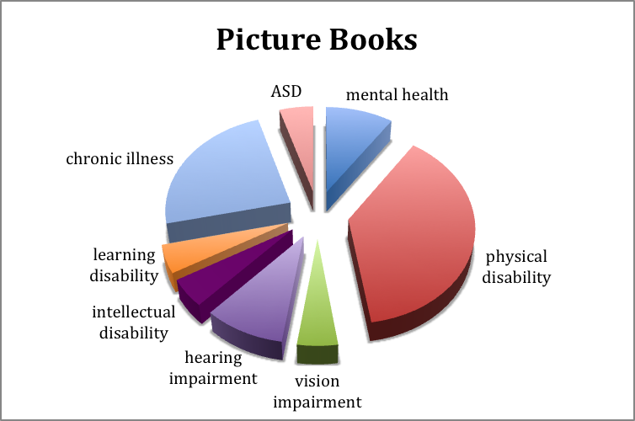
Several of the picture books blur reality with fantasy, in contrast to findings from an earlier study in which fantasy rarely appeared as a host genre to characters with disabilities in favour of realistic fiction (Author, 2010b). The picture books that verge toward fantasy usually begin with a factual story and gradually—perhaps through a dream, or a stream-of-consciousness narrative—become phantasmagorical. This genre-bending indicates the changing formats of Radical Change.
An interesting trend in picture books is the inclusion of adults as main characters. This has several implications in terms of activation of responses to characters with disaiblities. Children may better understand adults with challenges, such as aging grandparents who live with dementia In addition, adults with limited or declining reading abilities may find connections and more easily understandable text in particular picture books (Author, 2015). Radical Change is seen here as perspectives on picture books shift from child to intergenerational audiences.
Junior Novels
The 10 junior novels—for ages eight and up—represent a range of disabilities. While seven of the books have protagonists with a disability, three feature a friend or parent with a disability. Almost one-third of the characters have mental illness or emotional issues and another third have physical disabilities. In addition, visual impairment, chronic illness, learning disability, and intellectual disability add to the representation of disabilities.
Figure 2: Prevalence of Disabilities in Junior Novel Sample
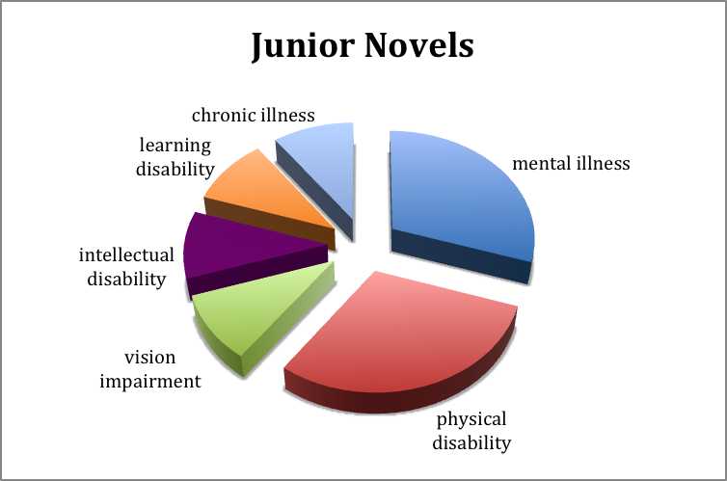
Intermediate Novels
The 50 intermediate novels (for readers age 11 and up) present about one-third of the characters with disabilities as primary characters and two-thirds as secondary characters. These novels offer more serious themes than found in the books for younger readers: de Vries’ (2011) Somebody’s Girl, for example, deals with adoption and the intricate emotions that accompany a new family dynamic.
A range of disabilities is represented in these novels: about a third are physical disabilities, almost one-quarter involve chronic illness, and a fifth are related to mental illness issues. Three of the seven characters with mental health disabilities are mothers of the protagonists, while men with mental illness are not represented in the study sample at all; a potentially troubling pattern.
Other disabilities represented are intellectual disabilities, learning disabilities, autism spectrum disorder (ASD), and hearing and vision impairments. Characters with multiple disabilities are not represented in these titles, a trend to examine in the future.
Figure 3: Prevalence of Disabilities in Intermediate Novel Sample
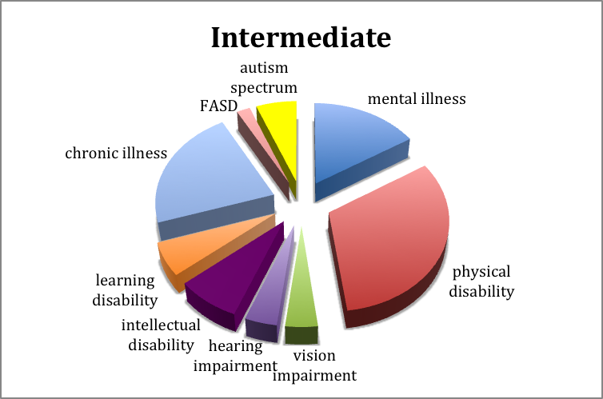
An emerging pattern in the intermediate novels involves blended genres. For example, Dyer’s (2002) Seeds of Time combines historical fiction and fantasy, and Lawrence’s (2006) Gemini Summer blends historical fiction with magic realism (Author, 2015). Blended genres are an example of the changing formats of Radical Change as storylines offer unpredictable turns. Most of the 50 intermediate novels are realistic fiction (28, including a series of three titles), while eight are fantasy, seven are historical fiction, four are steampunk, and three are magic realism.
Young Adult Novels
The young adult (YA) sample of 53 novels—for ages 14 and up—embraces even more sober subject matter with an overall darker tone than the titles for younger audiences. In the YA set, 12 teenagers are struggling with mental health issues, and at least eight characters have eating disorders. There are 15 teens with physical disabilities, nine with intellectual disabilities, four with ASD, and several youths with visual or hearing impairments, chronic illness, or learning disabilities.
Figure 4: Prevalence of Disabilities in Young Adult Novel Sample
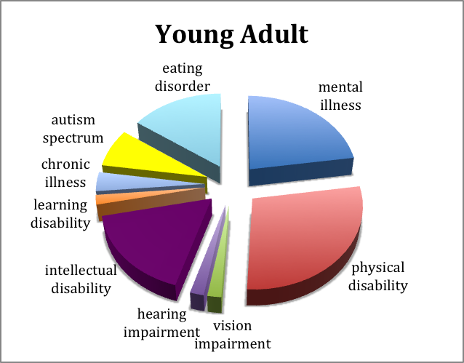
The young adult characters face real-world challenges, and do not always have happy endings. The content is mature, bridging youth and adult material, and the details are at times gritty.
This uncompromising content represents the changing perspectives within definitions of Radical Change. The serious themes invoke reader sympathy, and, in cases of abuse, a shattering sense of hardship experienced by the characters. It is possible that this type of realism—also experienced through digital sources—is something young readers want, an example of Radical Change at work (Author, 2015). Alternately, perhaps booksellers believe that these themes will sell to audiences hooked on realism they have encountered through other digital-age influences.
The genre of most of these 53 titles is realistic fiction; a few titles are magic realism, historical fiction, and fantasy. This pattern is consistent with the other novels in the study where realistic fiction appears most often when characters with disabilities are concerned, except in the set of picture books where blurred genres that include fantasy were more common and the intermediate novels where blended genres were found.

New Patterns and Trends
Titles portraying characters with disabilities are becoming more available in Canada than ever before (Author, 2015). Some are appearing on awards lists, such as the Dolly Gray award-winner, Waiting for No One, part two of a trilogy about a young woman with ASD (Author, 2010c). Characterizations involving more than one type of diversity are beginning to emerge, exemplified by Hopkinson’s (2012) The Chaos, featuring a 16-year-old girl with a gay friend in a wheelchair. There are also more non-fiction titles on the market considering exceptionality, for example, the respected book Downs: The History of a Disability (Wright, 2011), a resource for fiction writers portraying characters with disabilities. Another influence in the area of exceptionality is the authorship of books by those with disabilities, such as Born on a Blue Day (Tammet, 2007), a memoir of ASD.
Titles portraying exceptionality are increasing, especially for the intermediate and young adult age categories; picture books and junior novels are fewer in number. As exceptionality becomes understood as a basic part of human experience, it seems to increase in terms of placement in writers’ and publishers’ critical consciousness. These stories are certainly a means for changing societal attitudes where these texts authentically construct exceptionality as simply another aspect of diversity (Author, 2015).
Customarily, books on disability have often been written in a didactic tone as teaching aids (Author, 2014). This is changing, as evidenced by the titles in our sample. While the picture books and junior novels portray characters with disabilities in a realistic manner—making exceptionality just a part of a person rather than a main characteristic—the intermediate and young adult novels reveal disability through more sober subject matter with a somber tone, and real-world challenges that do not always end happily. These stories are complex, and often have unresolved endings, far different from moralistic teaching tales.
An interesting trend appearing in our sample of Canadian books involves two or more characters with disabilities helping one another, as in The Color of Silence (Shaw, 2013) in which a teenager becomes electively mute after a car accident and adapts through meeting another girl with limited body control and no speech. Another trend incorporates a secondary character with a disability: a brother, friend, mother, or grandfather of the story protagonist.
Other trends involve sports books involving a central character who learns to excel in a sport despite having a disability; at least 10 titles featuring eating disorders; and many high-interest, low reading-level books—indicating author or publisher insight regarding the provision of age-appropriate material for students with reading challenges (Author, 2015).
Textual Messages
In analyzing textual messages with respect to critical literacy, we consider the question, “What is exceptionality?” The answer varies. In the 21 picture books, it is depicted primarily as physical disability or chronic illness. In the 10 junior novels, almost one third of the characters have mental illness or emotional issues and another third have physical disabilities.
Figure 5: Prevalence of Disabilities in Canadian Children's Book Sample
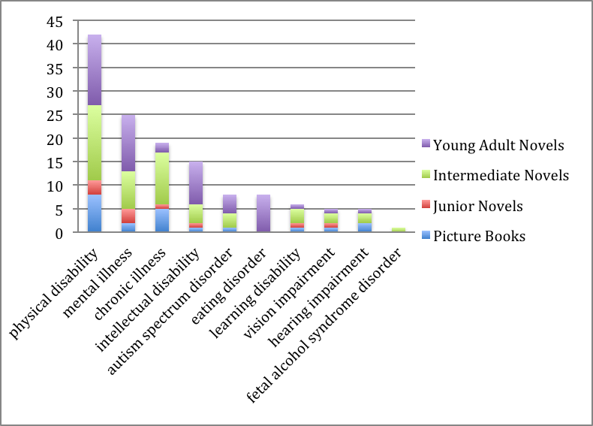

The 50 intermediate novels highlight a wide range of disabilities, principally physical disabilities, chronic illness, and mental illness. The 53 young adult titles portray the widest range of disabilities, highlighting physical disabilities, mental illness, intellectual disabilities, and eating disorders.

Overall, in our sample of picture books and junior, intermediate, and young adult novels, exceptionality is largely represented as physical disability, mental illness, chronic illness, and intellectual disability. In reality, the most common disabilities reported for Canadian children aged 5–14 are learning disabilities and chronic conditions (Employment and Social Development Canada, 2006). Canadians 15–24 years of age primarily experience mental or psychological disabilities, learning disabilities, and pain; and those 45–64 report pain, mobility, and flexibility issues (Statistics Canada, 2013). The frequent depiction of physical disabilities and chronic illness in our sample of books may be proportionate to the abundance of pain, mobility and flexibility issues in older adults. Moreover, the prevalence of mental illness in the children’s books in our sample may correspond to the incidence of mental or psychological disabilities in Canadian youth and young adults. However, the portrayal of intellectual disabilities in children’s books appears to be over-represented, while learning disabilities are under-represented. Also under-represented in our books are disabilities that involve multiple disability traits—such as ASD and, even more rarely seen in books, FASD.
As well as lacking in characterization of people with multiple disabilities, character portrayal in this sample of books tends to rely on a single form of difference—disability—without referring to other facets of being, such as sexual orientation or economic disparity. We predict that the effects of Radical Change will continue to affect and change the blend of diversity in these stories.
Regarding Radical Change—Dresang’s (1999) theory on the evolution of children’s books—the titles in our sample show evidence of changing forms and formats (such as blurred genres), changing boundaries (such as inclusion of serious subject matter), and changing perspectives (such as those of older adults). The depth and variety of characterizations of exceptionality—with many first-person perspectives emerging from primary characters—confirm the presence of innovation in this collection of books published over the past 20 years. This indicates that edgy, realistic textual messages predominate that can fuel classroom critical literacy discussions within social justice frameworks, inspiring teachers to ask students: “What does this book suggest about a person who is differently abled? Why might this message be given? Is it appropriate? What messages would you like to see in books that perhaps you are not seeing now?” Exceptionality as a basic human experience is gaining a place within literary artifacts, and through emphasizing critical consciousness in this regard, these stories can provide further means for changing societal perspectives about disability.
Future Research
One form of children’s book not discussed in this study is the graphic novel, a picture-oriented story resembling a comic book. There is limited research on characters with exceptionalities in graphic novels. An American study examining 30 high-quality graphic novels found that characters with disabilities were negatively stereotyped; females were pitiable and males were evil (Irwin & Moeller, 2010). This indicates that even the best of graphic novels has yet to reflect a realistic representation of exceptionality. This is a form to watch in future as the effects of Radical Change move the books into more authentic characterization.
Another interesting element to watch is the propensity for authors in this study to characterize physical disability as related to wheelchair use. Perhaps this is a convenient visual strategy, but it may represent a character’s lack of agency rather than a pathway to freedom. Again, this characterization will inevitably refine through Radical Change and its development will no doubt be intriguing.
Another area in which future research is indicated is Fetal Alcohol Spectrum Disorder (FASD), one of the categories least represented across the titles we explored. FASD is “a term referring to the continuum of effects that can occur in children, youth or adults prenatally exposed to alcohol. The spectrum of effects includes mild to severe cognitive, behavioral, physical and sensory disabilities” (FASD Support Network of Saskatchewan, 2009, p. 5). FASD appears to be a major cause of cognitive and developmental disabilities in Canadian children. In addition, secondary disabilities such as mental health challenges occur more frequently in populations with FASD, possibly related in part to social obstacles, and in part to biological mothers who use alcohol to self-medicate for mental health challenges of their own during pregnancy. While diagnoses related to FASD have been cited as the number one preventable cause of intellectual disability in the Western world, studies exist which show that the incidence of FASD is increasing (Eustace, Kang & Coombs, 2003). Considering that literature might be used to support understanding and prevention of FASD and yet is not utilized in this way is a subject definitely worth pursuing in further research.

Additional research on the topic of portrayals of disability in work for young people engages a stance of critical consciousness that considers education as transformative (Freire, 1983, 1991, 1998, 2005; Willis et al., 2008), and we encourage further attention to the nature of classroom resources and voices yet unheard in their number.
Conclusions
Reflecting on disability within an educational context in Canada, we return to the definition from Smith, Polloway, Patton, Dowdy, and Heath (2001) that includes the following categories of exceptionality: “learning disabilities, speech or language impairments, intellectual disabilities, emotional/behavioral disorders, multiple disabilities, auditory impairments, orthopedic impairments, other health impairments, visual impairments, autism ... and traumatic brain injury” (p. 7). While this interpretation was necessary to us in the gathering of titles along specific categories—in a lens we initially evaluated as authentic and wide—it also restricted us since many authors choose to write about disabilities that are not clearly defined, just as many people are differently abled without a particular diagnosis. Such a clear-cut categorization system may apply less in the future, in which we predict a greater blurring of boundaries as books continue to evolve towards rich and authentic portrayals rather than didactic projects designed to teach a lesson about the characteristics of a particular disability. Perhaps we can extend this argument further: definitions of disability have ordered funding mechanisms between governments and school divisions, yet currently many school divisions are receiving funding that is formula-based, relying on numbers of students in total, rather than diagnosis-based. Evidence that perceptions related to disability are changing.
Stories help us to understand ourselves and others. Educators must offer stories that matter to students. Researchers recognize and systematize the messages offered, forwarding thinking about contemporary titles. Writers create change—in others and themselves—from the inside out as they interrogate ways of being and communicate these through books and other types of texts (Author, 2015). As narratives that include exceptionalities become more authentic and abundant, we can become more appreciative of the diversity of lived lives, further affecting inclusive schools and communities.
Bibliography: Characters with Exceptionalities Portrayed in Contemporary Canadian Children’s Books
Picture Books
Chartrand, J., Nolan, D., & Chambers, J.M. (Illustrator). (2009). I want to be in the show. Winnipeg, MB: Pemmican Publications.
Cottin, M., Faria, R. (Illustrator), & Amado, E. (Translator). (2008). The black book of colors. Toronto, ON: Groundwood Books.
Day, Marie. (2002). Edward the "crazy man". Toronto ON: Annick Press.
Delaunois, A., & Delezenne, C. (Illustrator). (2011). The little yellow bottle. Toronto, ON: Second Story Press.
Domney, A., & Crawford, A. (Illustrator). (2011). Splish, splat! Toronto, ON: Second Story Press.
Epp, M., & Chrisholm, M. (Illustrator). (2007). Hope and the dragon. Mississauga, ON: Aspirations Publishing Inc.
Fitch, S., & Flook, H. (Illustrator). (2002). Pocket rocks. Victoria, BC: Orca Books.
Gilmore, R., & Sauve, G. (Illustrator). (1999). A screaming kind of day. Markham, ON: Fitzhenry & Whiteside.
Gregory, N., & Lightburn, R. (Illustrator). (1997). How Smudge came. Markham, ON: Red Deer Press.
Harrison, T., & Fernandes, E. (Illustrator). (1996). Aaron's awful allergies. Toronto, ON: Kids Can Press.
Hodge, D., & Brassard, F. (Illustrator). (2007). Lily and the mixed-up letters. Toronto, ON: Tundra Books.
Innes, S., Endrulat, H., & Deines, B. (Illustrator). (2012). A bear in war. Toronto, ON: Pajama Press.
Khan, R., & Fernandez, L., Jacobson, R. (Illustrators). (2001). King of the skies. Toronto ON: Scholastic/North Winds Press.
Levert, M. (2005). Eddie Longpants. Toronto, ON: Groundwood Books.
Maclear, K., & Arsenault, I. (Illustrator). (2012). Virginia Wolf. Toronto, ON: Groundwood Books.
Mitchell, K., & Upjohn, R. (2010). Patrick's wish. Toronto, ON: Second Story Press.
Munsch, R., & Martchenko, M. (Illustrator). (2012). Zoom. Markham, ON: Scholastic Canada.
Newhouse, M. (2010). The Weber Street Wonder Work Crew. Toronto, ON: Tundra Books.
Rivard, E., & Delisle, A. (Illustrator) (2011). Really and truly. Toronto, ON: Owlkids Books.
Yee, P., & Chan, H. (Illustrator). (1996). Ghost train. Toronto, ON: Groundwood Books.
Young, C. (2011). Ten birds. Toronto, ON: Kids Can Press.
Junior Novels
Cassidy, S. (2012). Seeing orange. Victoria, BC: Orca.
Citra, B. (2010). After the fire. Victoria, BC: Orca Books.
Gilmore, R. (1995). A friend like Zilla. Toronto, ON: Second Story Press.
Goobie, B. (2013). Jason’s why. Markham, ON: Red Deer Press.
Guest, J. (2011). Triple threat. Toronto, ON: James Lorimer.
Little, J. (2005). Forward, Shakespeare! Victoria, BC: Orca Books.
McDonnell, K. (2011). Emily included: A true story. Toronto, ON: Second Story Press.
Minaki, C. (2007). Zoe’s extraordinary holiday adventures. Toronto, ON: Second Story Press.
Peterson, L. (2008). Meeting Miss 405. Victoria, BC: Orca Books.
Richards, N. W. (2011). How to be a friend. Toronto, ON: Scholastic Canada.
Intermediate Novels
Armstrong, L. (2002). Jeannie and the gentle giants. Vancouver, BC: Ronsdale Press.
Author. (2007).
Baker, B. (2014). Camp Outlook. Toronto, ON: Second Story Press.
Carter, A.L. (2001). In the clear. Victoria, BC: Orca Books.
Chandler, A. (2008). Siena summer. Vancouver, BC: Tradewind Books.
Dyer, K.C. (2002). Seeds of time. Toronto, ON: Dundurn Press.
Dyer, K.C. (2003). Secret of light. Toronto, ON: Dundurn Press.
Dyer, K.C. (2005). Shades of red. Toronto, ON: Dundurn Press.
Dyer, K.C. (2007). Ms. Zephyr’s notebook. Toronto, ON: Dundurn Press.
Ellis, D. (1999). Looking for X. Toronto, ON: Groundwood Books.
Ellis, D. (2011). No ordinary day. Toronto, ON: Groundwood Books.
Findlay, J. (2011). The summer of permanent wants. Toronto, ON: Doubleday Canada.
Goto, H. (2002). The water of possibility. Regina: Coteau Books.
Haworth-Attard, B. (2002). Irish chain. Toronto, ON: HarperCollins.
Haworth-Attard, B. (2010). To stand on my own: The polio epidemic diary of Noreen Robertson. Toronto, ON: Scholastic Canada.
Horrocks, A. (2006). Almost Eden. Toronto, ON: Tundra Books.
Huser, G. (2003). Stitches. Toronto, ON: Groundwood.
Jennings, S. (2006). Pump. Toronto, ON: HIP Books.
Johansen, K.V. (2007). Torrie & the snake-prince. Toronto, ON: Annick Press.
Lawrence, I. (2006). Gemini summer. New York, NY: Delacorte Press.
Leavitt, M. (2004). Heck superhero. Red Deer Press.
Lekich, J. (2002). The losers’ club. Toronto, ON: Annick Press.
Linden, D. (2013). On fire. Saskatoon, SK: Thistledown Press.
Little, J. (2000). Willow and Twig. Toronto, ON: Penguin Canada.
MacDonald, A.L. (2009). Seeing red. Toronto, ON: Kids Can Press.
McBay, B., & Heneghan, J. (2003). Waiting for Sarah. Victoria, BC: Orca Books.
McMurchy-Barber, G. (2010). Free as a bird. Toronto, ON: Dundurn Publishers.
Mercer, A. (2011). Rebound. Toronto, ON: James Lorimer.
Mulder, M. (2011). Out of the box. Victoria, BC: Orca.
Muller, R.D. (2009). The solstice cup. Victoria, BC: Orca.
Nelson, C. (2011). Tori by design. Winnipeg, MB: Great Plains Publications.
Nielsen, S. (2012). The reluctant journal of Henry K. Larsen. Toronto, ON: Tundra Books.
Nugent, C. (2004). Francesca and the magic bike. Vancouver, BC: Raincoast Books.
Oppel, K. (2007). Darkwing. Toronto, ON: HarperCollins.
Porter, P. (2005). The crazy man. Toronto, ON: Groundwood Books.
Rayner, R. (2011). Out of sight. Toronto, ON: James Lorimer.
Rivers, K. (2012). The encyclopedia of me. New York, NY: Arthur A. Levine Books.
Rud, J. (2008). Paralyzed. Victoria, BC: Orca Books.
Shaw, L. (2013). The color of silence. Toronto, ON: Second Story Press.
Slade, A. (2009). The hunchback assignments. Toronto, ON: HarperCollins.
Slade, A. (2010). The dark deeps. Toronto, ON: HarperCollins.
Slade, A. (2011). Empire of ruins. Toronto, ON: HarperCollins.
Slade, A. (2012). The island of doom. Toronto, ON: HaperCollins.
Spring, D. (2008). Breathing soccer. Saskatoon, SK: Thistledown Press.
Waldman, D. (2011). Addy’s race. Victoria, BC: Orca Book Publishers.
Walters, E. (2000). Rebound. Toronto, ON: Stoddart Kids.
Walters, E. (2003). Run. Toronto, ON: Penguin Books.
Walters, E. (2005). Elixir. Toronto, ON: Penguin Books.
Walters, E. (2009). Special Edward. Victoria, BC: Orca Books.
Watson, J. (2013). Prove it, Josh. Winlaw, BC: Sono Nis Press.
Young Adult Novels
Aker, D. (2007) The space between. Toronto, ON: HarperCollins.
Andrews J. (2013). The silent summer of Kyle McGinley. Winnipeg, MB: Great Plains Teen Fiction.
Austin, C. (2011). All good children. Victoria, BC: Orca.
Author. (2005).
Author. (2010c).
Author. (2012).
Bell, W. (2006). The blue helmet. Random House of Canada.
Bobet, L. (2012). Above. New York, NY: Arthur A. Levine.
Butcher, K. (2012). Truths I learned from Sam. Toronto, ON: Dundurn.
Choyce, L. (2004). Smoke and mirrors. Toronto, ON: Dundurn Press.
Davey, D. (2013). M in the abstract. Markham, ON: Red Deer Press.
Denman, K.L. (2008). Spiral. Victoria, BC: Orca Books.
Denman, K.L. (2009). Me, myself and Ike. Victoria, BC: Orca.
Diersch, S. (2011). Ceiling stars. Toronto, ON: James Lorimer.
Ellis, D. (2011). True blue. Toronto, ON: Pajama Press.
Fairfield, L. (2009). Tyranny. Toronto, ON: Tundra Books.
Firmston, K. (2012). Schizo. Toronto, ON: James Lorimer.
Fournier, K. M. (2007). Sandbag shuffle. Saskatoon, SK: Thistledown Press.
Frizzell, C. (2006). Chill. Victoria, BC: Orca Books.
Froese, D. (2002). Out of the fire. Toronto, ON: Sumach Press.
Gingras, C. (2009). Pieces of me (S. Ouriou, Trans.). Toronto, ON: Kids Can Press.
Goobie, B. (2002). Kicked out. Victoria, BC: Orca Books.
Holeman, L. (2002). Search of the moon king’s daughter. Toronto, ON: Tundra Books.
Janz, H. (2004). Sparrows on wheels. Edmonton, AB: DocCrip Press.
Johnston, J. (2006). A very fine line. Toronto, ON: Tundra Books.
Ketchen, S. (2012). Grows that way. Fernie, BC: Oolichan.
Kropp, P. (2004). Against all odds. Toronto, ON: HIP Books.
McKay, S. (2000). Charlie Wilcox. Toronto, ON: Penguin Books.
McLintock, N. (2008). Dead silence. Toronto, ON: Scholastic.
McNicoll, S. (2003). A different kind of beauty. Markham, ON: Fitzhenry & Whiteside.
McNicoll, S. (2006). Beauty returns. Markham, ON: Fitzhenry & Whiteside.
Nicholson, L.S. (2012). Vegas tryout. Toronto, ON: James Lorimer.
Polak, M. (2011). Miracleville. Victoria, BC: Orca.
Robins, T. (2013). Objects in mirror. Markham, ON: Red Deer Press.
Roorda, J. (2007). Wings of a bee. Toronto, ON: Sumach Press.
Ryan, D. (2012). Cuts like a knife. Victoria, BC: Orca.
Scarsbrook, R. (2010). The monkeyface chronicles. Saskatoon, SK: Thistledown Press.
Scrimger, R. (2012). Ink me. Victoria, BC: Orca.
Shaw, L. (2009). Thinandbeautiful.com. Toronto, ON: Second Story Press.
Shaw, L. (2011). Fostergirls. Toronto, ON: Second Story Press.
Shaw, L. (2013). The colour of silence. Toronto, ON: Second Story Press.
Skrypuch, M. (1999). The hunger. Toronto, ON: Boardwalk Books.
Sobat, G.S. (2008). Gravity journal. Winnipeg, MB: Great Plains Publications.
Spring, D. (2010). The kayak. Saskatoon, SK: Thistledown Press.
Stevenson, R. (2008). Big guy. Victoria, BC: Orca Books.
Stinson, K. (2012). What happened to Ivy. Toronto, ON: Second Story Press.
Tokio, M. (2003). More than you can chew. Tundra Books.
Toten, T. (2013). The unlikely hero of room 13B. Toronto, ON: Doubleday.
Trembath, D. (1996). The Tuesday café. Victoria, BC: Orca Books.
Trembath, D. (2005). Rooster. Victoria, BC: Orca Books.
Tullson, D. (2006). Zero. Markham, ON: Fitzenry & Whiteside.
Tullson, D. (2009). Riley Park. Victoria, BC: Orca.
Waldorf, H. (2008). Tripping. Calgary, AB: Red Deer Press.

References
Author. (2010a).
Author. (2010b).
Author. (2010c).
Author. (2013).
Author. (2014).
Author. (2015).
Berg, B. L. (2009). Qualitative research methods for the social sciences (7th ed.). Toronto: Allyn & Bacon.
Dresang, E. T. (1999). Radical change: Books for youth in a digital age. New York: H. W. Wilson.
Dresang, E. T., & Kotrla, B. (2009). Radical change theory and synergistic reading for digital age youth. Journal of Aesthetic Education, 43(2), 92 –107.
Dyches, T. T., & Prater, M. A. (2000). Developmental disability in children’s literature: Issues and annotated bibliography. Reston, VA: Council for Exceptional Children, Division on Mental Retardation and Developmental Disabilities.
Dyches, T. T., Prater, M. A., & Cramer, S. F. (2001). Characterization of mental retardation and
autism in children’s books. Education and Training in Mental Retardation and Developmental Disabilities, 36(3), 230 – 243.
Employment and Social Development Canada. (2006). Disability in Canada: A 2006 profile. Retrieved from www.esdc.gc.ca/eng/disability/arc/disability_2006.shtml
FASD Support Network of Saskatchewan. (2009). Retrieved from http://www.skfasnetwork.ca/
Freire, P. (1983). Pedagogy of the oppressed (M. B. Ramos, Trans.). New York: Continuum. (Original work published 1970).
Freire, P. (1991). The importance of the act of reading. In B. Power, & R. Hubbard (Eds.), Literacy in process (pp. 21 – 26). Portsmouth, NH: Heinemann.
Freire, P. (1998, 2005). Teachers as cultural workers: Letters to those who dare teach (D. Macedo, D. Koike, & A. Oliveira, Trans.). Cambridge, MA: Westview Press.
Garland-Thomson, R. (2006). Integrating disability, transforming feminist theory. In L. J. Davis (Ed.), The disability studies reader (2nd ed., pp. 257 – 273). New York: Routledge.
Greenwell, B. (2004). The curious incident of novels about asperger’s syndrome. Children’s Literature in Education, 35(3), 271 – 284.
Hopkinson, N. (2012). The chaos. Toronto, ON: Margaret K. McElderry Books.
Irwin, M., & Moeller, R. (2010). Seeing different: Portrayals of disability in young adult graphic novels. School Library Research, 13. Retrieved from www.ala.org/aasl/sites/ala.org.aasl/ files/content/aaslpubsandjournals/slr/vol13/SLR_SeeingDifferent.pdf.
Lewison, M., Flint, A. S., & Van Sluys, K. (2002). Taking on critical literacy: The journey of newcomers and novices. Language Arts, 79(5), 382 – 392.
Luke, A., & Freebody, P. (1997). Shaping the social practices of reading. In S. Muspratt, A. Luke & P. Freebody (Eds.), Constructing critical literacies: Teaching and learning textual practice (pp. 185 – 225). Cresskill, NJ: Hampton Press.
MacDonald, A.L. (2009). Seeing red. Toronto, ON: Kids Can Press.
Merriam, S. B. (1998). Qualitative research and case study applications in education: Revised and expanded from case study research in education. San Francisco: Jossey-Bass.
Mills, C. (2002). The portrayal of mental disability in children’s literature: An ethical appraisal. The Horn Book Magazine, 78(5), 531 – 542.
Pajka-West, S. (2007). Perceptions of deaf characters in adolescent literature. ALAN Review, 34 (3), 39 – 45.
Seidman, I. (2006). Interviewing as qualitative research: A guide for researchers in education and the social sciences (3rd ed.). New York: Teachers College Press.
Shaw, L. (2013). The color of silence. Toronto, ON: Second Story Press.
Sherry, M. (2008). Reading me/Me reading disability. In B.J. Brueggemann & M.E. Lupo (Eds.), Disability and/in prose (pp. 153 – 165). New York: Routledge.
Smith, T.E.C., Polloway, E.A., Patton, J.R., Dowdy, C.A., & Heath, N.L. (2001). Teaching students with special needs in inclusive settings (Canadian ed.). Toronto, ON: Pearson.
Smith, T.E.C., Polloway, E.A., Patton, J.R., Dowdy, C.A., & McIntyre, L.J. (2012). Teaching students with special needs in inclusive settings. (4th Canadian ed.). Toronto, ON: Pearson.
Statistics Canada. (2013). Canadian Survey on Disability 2012: Prevalence of disability for adults by sex and age group. Catalogue no. 89-654-X, Ottawa, ON. Retrieved from www4.rhdcc.gc.ca/indicator.jsp?&indicatorid=40#M_1
Tammet, D. (2007). Born on a blue day: Inside the extraordinary mind of an autistic savant. Toronto, ON: Simon & Schuster Canada.
Willis, A.I., Montavon, M., Hall, H., Hunter, C., Burke, L., & Herrera, A. (2008). Critically conscious research: Approaches to language and literacy research. New York: Teachers College Press.
Wright, D. (2011). Downs: The history of a disability. Oxford: Oxford University Press.

